Senior Deep Learning Project Framework (25 Steps)
Use this exact framework for every Deep Learning & Computer Vision project.

PHASE 1 — Product & Research
Step | Deliverable
01 | Business Problem & Domain Understanding
02 | Project Objectives & Success Criteria
03 | Literature Review (ResNet, YOLO, U-Net, papers)
04 | Dataset Study & Data Dictionary
05 | Repository & System Architecture
Output: Project proposal, README draft, architecture diagram.

PHASE 2 — Data Engineering
Step | Deliverable
06 | Environment Setup (PyTorch, CUDA, Seeds)
07 | Data Collection / Download Pipeline
08 | Exploratory Data Analysis (EDA)
09 | Data Cleaning & Quality Checks
10 | Preprocessing Pipeline
11 | Data Augmentation Strategy
12 | Dataset & DataLoader Implementation
Output: Reproducible data pipeline.

PHASE 3 — Model Development
Step | Deliverable
13 | Baseline Model (Simple CNN)
14 | Final Architecture (ResNet/YOLO/U-Net/ViT)
15 | Loss Functions & Optimization
16 | Training Engine
17 | Validation Strategy
18 | Hyperparameter Experiments
Output: Best trained model (best_model.pth).

PHASE 4 — Evaluation & Explainability
Step | Deliverable
19 | Performance Metrics
20 | Confusion Matrix & Curves
21 | Error Analysis
22 | Explainability (Grad-CAM, Attention Maps)
Output: Complete model analysis report.

PHASE 5 — Production AI
Step | Deliverable
23 | Inference Pipeline
24 | Deployment (FastAPI + Docker)
25 | Documentation, Testing & GitHub Release
Output: Production-ready AI application.

Professional repository structure
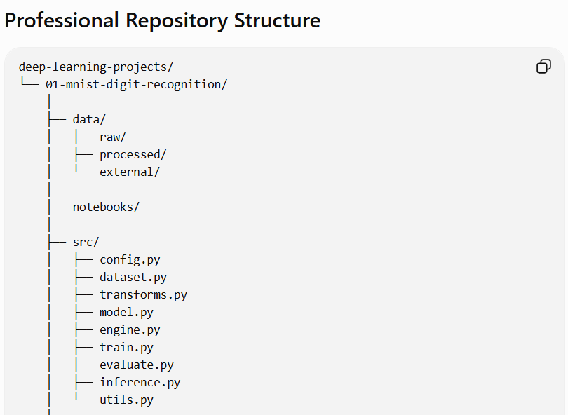
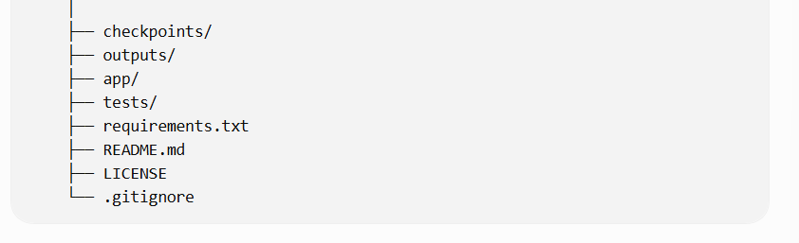

MNIST Handwritten Digit Recognition using CNN

Step 01: Project Definition

1. Business Problem

Industry Context
Millions of handwritten digits appear every day in:
- Bank cheques
- Postal codes
- Government forms
- Student examination papers
- Hospital registration forms
Manual digit entry is slow, expensive, and prone to human error.

Business Need
Develop an AI system that can automatically recognize handwritten digits from scanned grayscale images with very high accuracy.

Proposed AI Solution
A Convolutional Neural Network (CNN) will learn visual patterns from handwritten digits and predict the correct number (0–9).

2. Project Objective

Primary Objective
Build a CNN capable of classifying handwritten digits into 10 classes.

Input
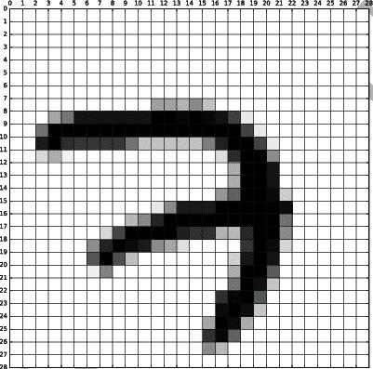
- Image size: 28 × 28 pixels
- Color channels: 1 (Grayscale)
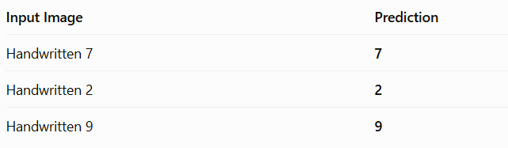
The model outputs the probability of each class, and the highest probability becomes the prediction.

3. Problem Type
Property | Value
AI Domain | Deep Learning
Specialization | Computer Vision
Task | Image Classification
Learning Type | Supervised Learning
Framework | PyTorch

4. Success Criteria
Our project is considered successful when it meets these targets.
Metric | Target
Test Accuracy | ≥ 99%
Precision | ≥ 99%
Recall | ≥ 99%
F1 Score | ≥ 99%
Inference Speed | Less than 20 ms/image

5. Real-World Applications
This same pipeline extends directly into larger Computer Vision systems.

Banking
Cheque digit recognition

Postal Services
ZIP code automation
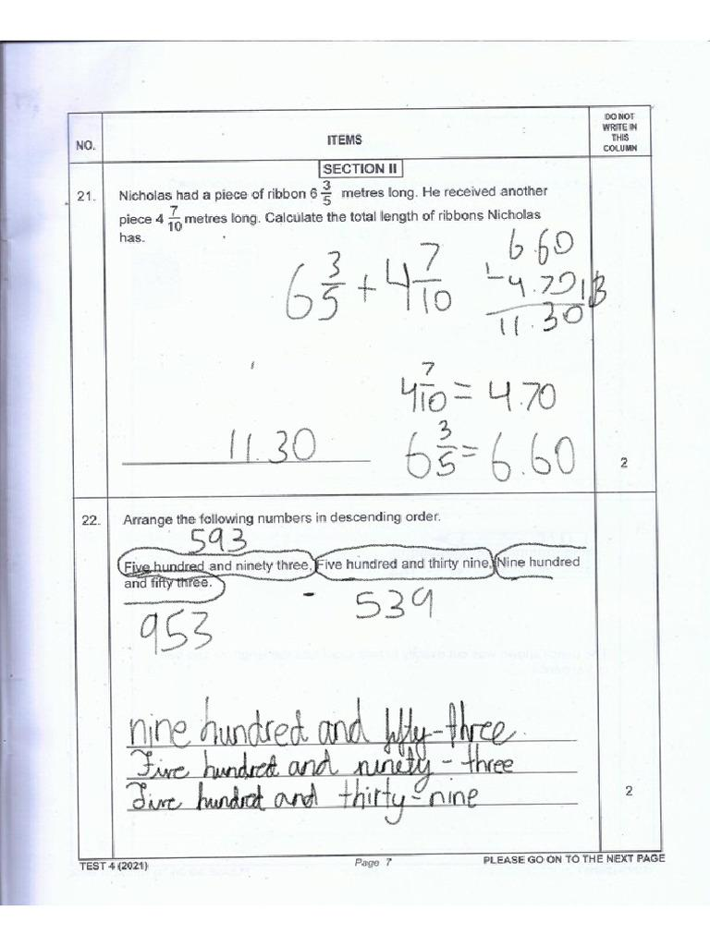
Education
Automatic score digitization
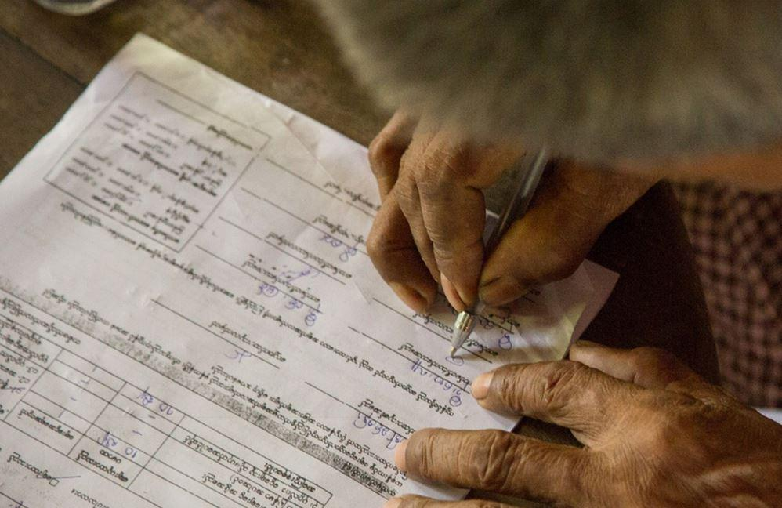
Government
Digital form processing

6. Functional Requirements
The finished application must be able to:
- Accept a handwritten image
- Preprocess it automatically
- Predict the digit
- Return confidence scores
- Save the trained model
- Expose prediction through an API

7. Non-Functional Requirements
Requirement | Description
Reproducibility | Same results using fixed random seeds
Scalability | Easy to replace CNN with ResNet later
Maintainability | Modular source code
Performance | GPU support (CUDA)
Documentation | Professional README

8. Technical Stack
Component | Technology
Language | Python 3.13
Deep Learning | PyTorch
Dataset | MNIST
Visualization | Matplotlib
Metrics | scikit-learn
API | FastAPI
Version Control | Git + GitHub

9. Expected Deliverables
By the end of this project, your repository will contain:
- Complete CNN architecture
- Training pipeline
- Validation pipeline
- Evaluation report
- Confusion matrix
- Loss & accuracy curves
- best_model.pth
- Inference script
- FastAPI REST API
- Professional GitHub README

10. Project Milestone
Step 01 Completed
Business problem defined
Objectives defined
Success metrics established
Technical stack selected
Deliverables finalized

Step 02: Dataset Study

1. Dataset Overview

What is MNIST?
MNIST (Modified National Institute of Standards and Technology) is the most widely used handwritten digit dataset in Deep Learning. It contains grayscale images of digits from 0 to 9.
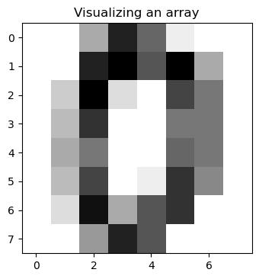
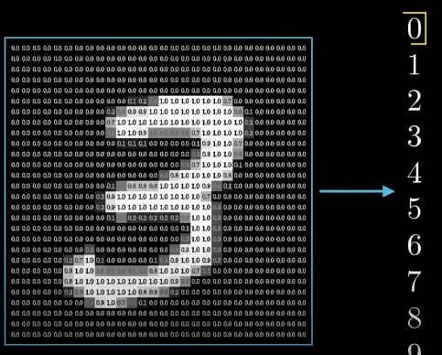
7
It is considered the "Hello World" of Computer Vision because it teaches CNN fundamentals without unnecessary complexity.

2. Business Understanding
Imagine a bank receives 100,000 handwritten cheques every day.
Instead of a human reading every number:
The same concept later scales to medical images, satellite images, and autonomous vehicles.

3. Dataset Source
Property | Value
Name | MNIST
Creator | Yann LeCun et al.
Domain | Computer Vision
Task | Image Classification
Classes | 10
Color | Grayscale
In PyTorch, the dataset is downloaded automatically through torchvision.datasets.MNIST.

4. Dataset Statistics
Item | Value
Total Images | 70,000
Training Images | 60,000
Test Images | 10,000
Number of Classes | 10
Image Width | 28 px
Image Height | 28 px
Channels | 1

Dataset Split

We will later create our own validation set from the training images.

5. Class Labels
The model predicts one of these ten classes.
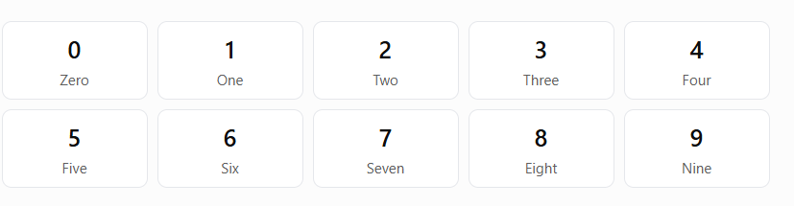
This is a multi-class classification problem.
y∈{0,1,2,3,4,5,6,7,8,9}

6. Image Structure
Every image has the same dimensions.
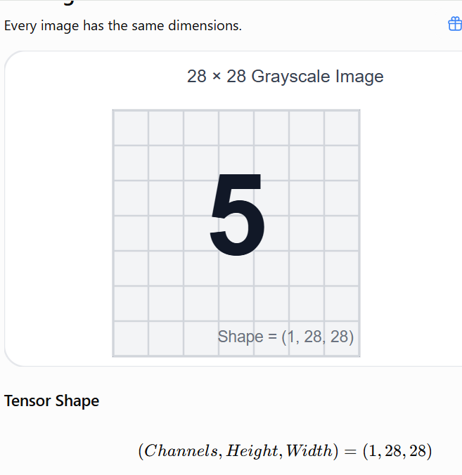
Unlike RGB images:
Image Type | Shape
MNIST | (1, 28, 28)
CIFAR-10 | (3, 32, 32)
Medical X-ray | (1, H, W)

7. Pixel Values
Pixels are stored as integers.
Color | Value
Black | 0
Gray | 127
White | 255
Before training, we'll normalize them into:
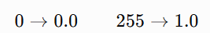
This helps the CNN train faster and more stably.

8. Class Distribution
MNIST is almost perfectly balanced.
MNIST class distribution
Approximate training images per digit; classes are nearly balanced.
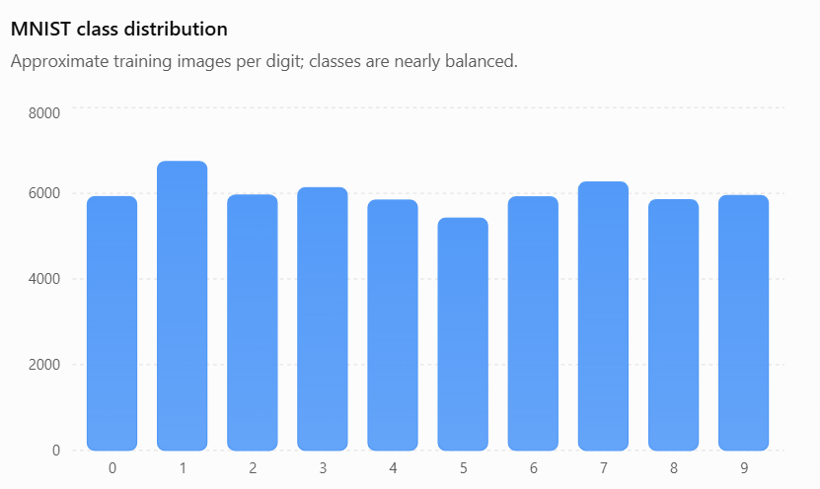
Observation
- No severe imbalance
- No oversampling needed
- Accuracy is a reliable metric
Later medical datasets will not be this balanced.

9. Challenges of MNIST
Although MNIST is simple, it still contains difficult cases.
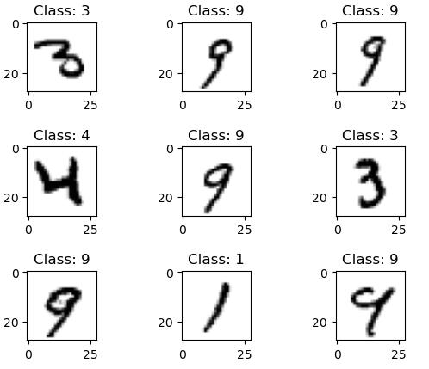
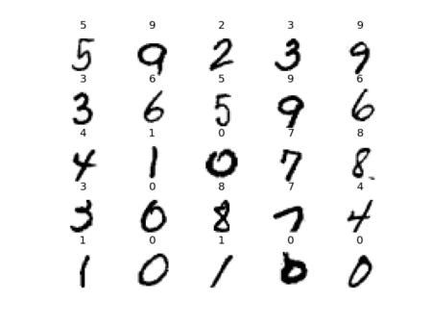
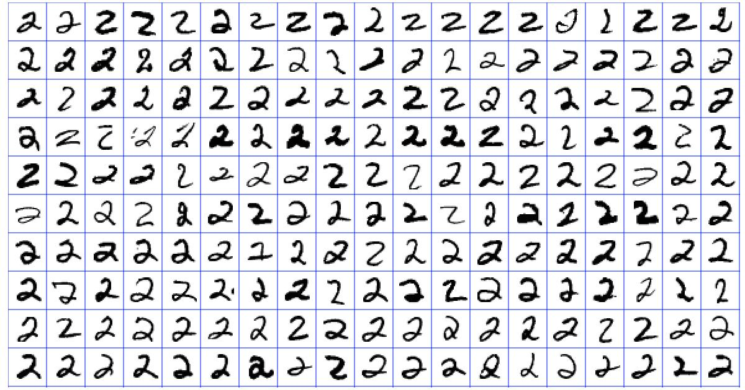
Common issues:
- Different handwriting styles
- Rotation
- Thick or thin strokes
- Noise
- Similar-looking digits (4 vs 9, 3 vs 5)
These are the reasons we use data augmentation later.

10. Validation Strategy
We will not train directly on all 60,000 images.

Split | Images
Train | 54,000
Validation | 6,000
Test | 10,000
Why?
- Train: learn patterns
- Validation: tune hyperparameters
- Test: final unbiased evaluation

Step 03: Project Architecture
A senior deep learning engineer does not start with model code. The first task is designing a scalable architecture so the project is easy to maintain, test, and extend.
Goal: Build a production-style repository that can later support ResNet, YOLO, U-Net, and Vision Transformers with minimal changes.

1. System Architecture

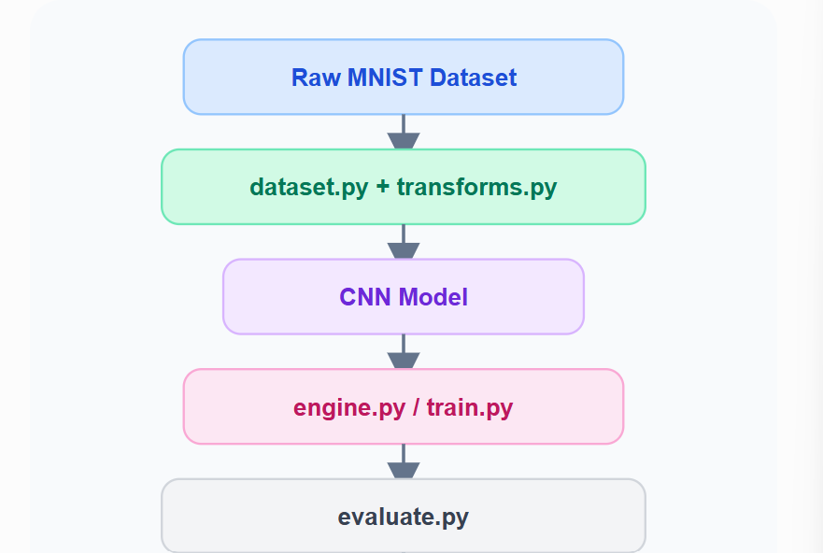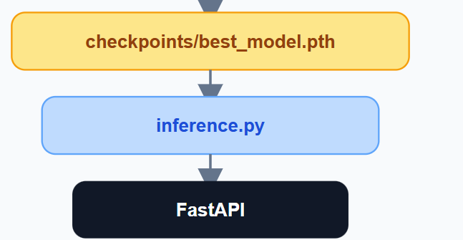
This is the complete flow of the project—from raw images to a deployed AI service.

2. Repository Structure

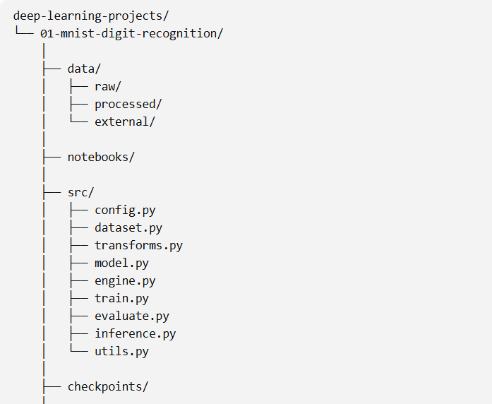

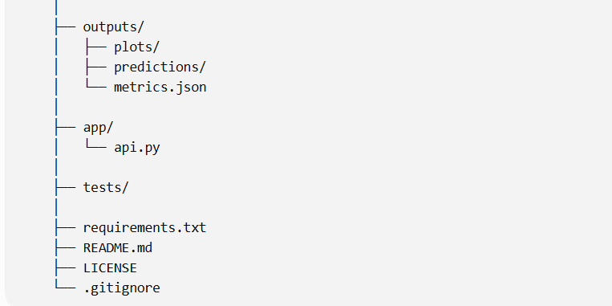

3. What Each Folder Does
data/
Stores raw, processed, and external datasets. We never modify the raw dataset directly.
notebooks/
Used only for experimentation and visualization. Final training logic does not stay here.
src/
The heart of the project. Every reusable module lives here.
checkpoints/
Contains the best trained model (.pth) and optional epoch checkpoints.
outputs/
Stores plots, predictions, confusion matrices, and metrics.
app/
Production API using FastAPI.
tests/
Unit tests for preprocessing and inference.

4. Source Code Architecture
The src/ folder follows the Single Responsibility Principle: each file has one job.
File | Responsibility
config.py | Hyperparameters & paths
dataset.py | Load MNIST dataset
transforms.py | Preprocessing & augmentation
model.py | CNN architecture
engine.py | Training & validation loops
train.py | Main training entry point
evaluate.py | Metrics & confusion matrix
inference.py | Predict new images
utils.py | Helper functions
This separation makes projects easy to debug and reuse.

5. Data Flow
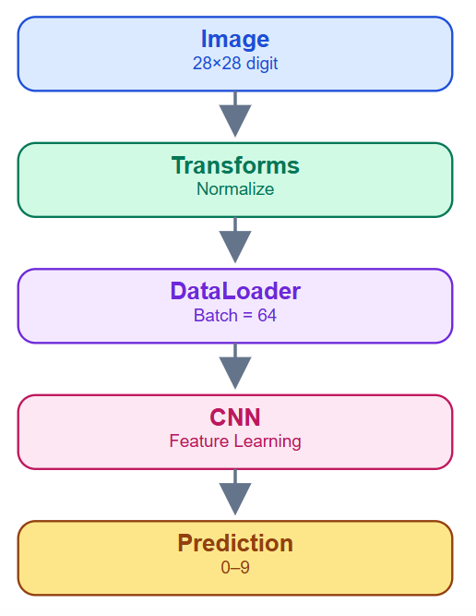
Every future project (ResNet, YOLO, U-Net) follows this same pipeline.

6. Configuration System
A senior project never hardcodes values throughout the code.
Instead, one configuration file controls everything.
Category | Examples
Dataset | Image size, channels
Training | Epochs, batch size
Optimizer | Learning rate
Hardware | CPU / CUDA
Paths | Data & checkpoints
Later, changing from MNIST to CIFAR-10 should require changing only configuration values—not rewriting the entire project.

7. Checkpoint Strategy
We save only the best performing model.

We do not automatically keep every epoch forever.
Artifacts:
- Best weights
- Metrics
- Loss curves
- Confusion matrix

8. Engineering Principles
These are the standards we'll follow in all 20 projects.
Principle | Why it matters
Modularity | Easy to replace CNN with ResNet
Reproducibility | Same results every run
Scalability | Reuse code across projects
Readability | Clean, maintainable code
Separation of Concerns | One responsibility per file

Step 04: Environment Setup
This step creates a reproducible development environment. A senior engineer ensures that anyone who clones the repository can run the project with the same results.
Goal: Prepare the project, virtual environment, CUDA, and dependencies.

1. Create the Project
Inside your deep-learning-projects repository:
deep-learning-projects/
│
└── 01-mnist-digit-recognition/

Create the folder
mkdir 01-mnist-digit-recognition
cd 01-mnist-digit-recognition

2. Create a Virtual Environment
We isolate project dependencies.

Windows
python -m venv .venv

Activate
.venv\Scripts\activate
If activation is successful, your terminal becomes:
(.venv) C:\deep-learning-projects\01-mnist-digit-recognition>

3. Install Dependencies

Core Deep Learning
pip install torch torchvision torchaudio

Data Science
pip install numpy pandas matplotlib scikit-learn

API
pip install fastapi uvicorn

Utilities
pip install tqdm pillow

4. Verify CUDA
Run:
import torch

print(torch.__version__)
print(torch.cuda.is_available())
print(torch.cuda.get_device_name(0))
Expected output (your laptop):
2.x.x
True
NVIDIA GeForce RTX 3070 Laptop GPU
If True appears, PyTorch is using your GPU.

5. Project Directory
Create these folders now.

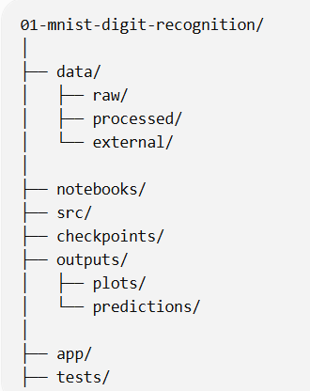

6. Create Empty Source Files
src/
│
├── config.py
├── dataset.py
├── transforms.py
├── model.py
├── engine.py
├── train.py
├── evaluate.py
├── inference.py
└── utils.py
We're only creating them now—not writing code yet.

7. requirements.txt
A professional repository always contains dependency versions.
torch
torchvision
torchaudio
numpy
pandas
matplotlib
scikit-learn
fastapi
uvicorn
tqdm
pillow
Later we'll freeze exact versions using:
pip freeze > requirements.txt

8. .gitignore
Never upload unnecessary files.
.venv/
__pycache__/
*.pyc

data/raw/
checkpoints/

outputs/

.ipynb_checkpoints/
Notice we ignore:
- Virtual environment
- Raw dataset
- Model weights
- Generated outputs
This keeps GitHub clean.

9. Reproducibility Strategy
Every future experiment must produce consistent results.
Component | Purpose
Random Seed | Same data shuffling
NumPy Seed | Consistent preprocessing
PyTorch Seed | Same initialization
CUDA Seed | Reproducible GPU training
We'll implement this inside config.py in the next coding step.

10. Environment Checklist
Before moving on, your project should look like this:
- Virtual environment created
- PyTorch installed
- CUDA detected
- Repository folders created
- Source files created
- requirements.txt added
- .gitignore added

Step 05: Data Loading
This is the first coding step of the project. Our objective is to build a clean, reusable data pipeline—not just load MNIST in one notebook.
Goal: Create dataset.py and prepare train, validation, and test DataLoaders.

1. Why DataLoader Matters
A CNN never reads one image at a time. Instead, images are loaded in mini-batches for efficient GPU training.
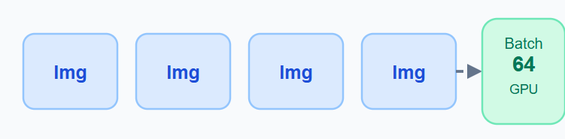
Instead of:
- Image 1
- Image 2
- Image 3
We process:
- 64 images simultaneously
This makes GPU training dramatically faster.

2. Data Pipeline Architecture
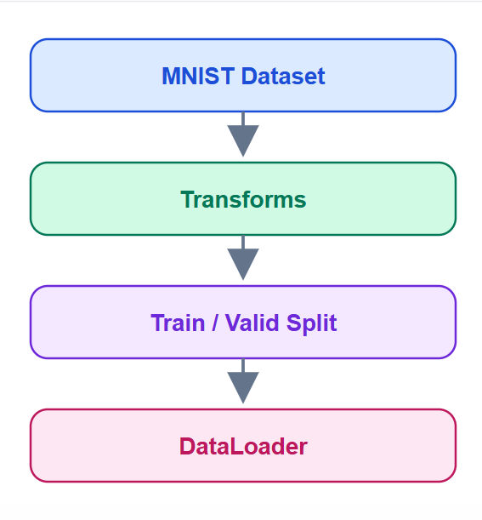
Each stage has one responsibility.

3. Train / Validation / Test Strategy
We do not train using all 60,000 training images.
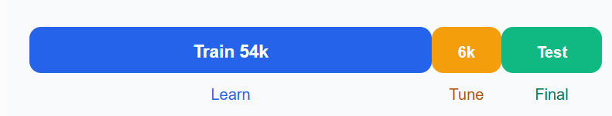
Split | Images | Purpose
Train | 54,000 | Learn weights
Validation | 6,000 | Tune model
Test | 10,000 | Final evaluation
A senior engineer never touches the test set during training.

4. dataset.py Responsibilities
This file should do only four things:
- Download MNIST
- Apply transforms
- Split training into train/validation
- Return DataLoaders
It should not contain model or training logic.

5. Batch Size Concept
Suppose we have 54,000 images.
54000/64=844 batches per epoch
Meaning:
- One epoch = 844 batches
- Each batch = 64 images
- GPU updates weights after every batch
This is why batch_size is an important hyperparameter.

6. DataLoader Configuration
Parameter | Value | Reason
Batch Size | 64 | Efficient GPU usage
Shuffle | True (train) | Random learning
Shuffle | False (test) | Consistent evaluation
Num Workers | 2–4 | Faster loading
Pin Memory | True | Faster CUDA transfer
These settings are standard for PyTorch projects.

7. Expected Tensor Shapes
When one batch is loaded:

Meaning:
- 64 images
- 1 channel
- 28×28 pixels
- 64 corresponding labels

8. Data Quality Checks
Before training, always verify:
Check | Expected
Number of classes | 10
Image shape | 1×28×28
Pixel range | 0–1 after normalization
Train batches | 844
Test batches | 157
These checks prevent silent bugs later.

9. Files Created in This Step
src/
├── dataset.py
└── transforms.py
Their responsibilities:
- transforms.py → preprocessing & augmentation
- dataset.py → DataLoader creation
We'll implement them in the next coding lesson without mixing responsibilities.

Data Loading Implementation
Now we write our first production-quality code.
Goal: Build a reusable PyTorch data pipeline.

File 1 — src/config.py
This file stores all project configurations in one place.
from pathlib import Path
import torch

# ==========================
# Project Paths
# ==========================
PROJECT_ROOT = Path(__file__).resolve().parent.parent

DATA_DIR = PROJECT_ROOT / "data"
CHECKPOINT_DIR = PROJECT_ROOT / "checkpoints"
OUTPUT_DIR = PROJECT_ROOT / "outputs"

# Create folders automatically
CHECKPOINT_DIR.mkdir(parents=True, exist_ok=True)
OUTPUT_DIR.mkdir(parents=True, exist_ok=True)

# ==========================
# Dataset
# ==========================
IMAGE_SIZE = 28
NUM_CLASSES = 10
CHANNELS = 1

# ==========================
# Training
# ==========================
BATCH_SIZE = 64
VALID_SPLIT = 0.10
SEED = 42

# ==========================
# Device
# ==========================
DEVICE = "cuda" if torch.cuda.is_available() else "cpu"

What is config.py?
Instead of writing values like 64, 42, or "cuda" throughout your code, you define them once in config.py and import them everywhere.
Bad practice:
batch_size = 64
...
batch_size = 64
...
batch_size = 64
If you want to change it to 128, you must edit many files.
Good practice:
# config.py
BATCH_SIZE = 64
Then every file uses:
from .config import BATCH_SIZE
Change it once, and the whole project updates.
-------------------------------------------------------------------

1. Why Path?
from pathlib import Path
Path is Python's modern way to work with folders.
Instead of writing Windows paths:
"C:\\Users\\hp\\project\\data"
we write:
PROJECT_ROOT / "data"
It works on Windows, Linux, and macOS automatically.

2. Understanding PROJECT_ROOT
PROJECT_ROOT = Path(__file__).resolve().parent.parent
This looks difficult, but it's just finding the project folder.
Suppose this file is located here:
01-mnist-digit-recognition/
│
└── src/
└── config.py

__file__
Means:
src/config.py

.parent
Goes one folder up.
src/

.parent.parent
Goes up again.
01-mnist-digit-recognition/
Visualization:
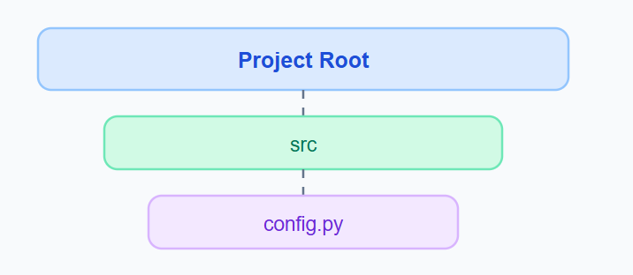
Now every other path starts from the project root.

3. Why create directories?
DATA_DIR = PROJECT_ROOT / "data"
This becomes:
.../01-mnist-digit-recognition/data
Similarly:
CHECKPOINT_DIR = PROJECT_ROOT / "checkpoints"
becomes:
.../checkpoints
No hardcoded paths.

4. What does mkdir() do?
CHECKPOINT_DIR.mkdir(parents=True, exist_ok=True)
Imagine the folder doesn't exist.
Before:
project/
After running:
project/
│
└── checkpoints/

Parameters
Argument | Meaning
parents=True | Create parent folders if needed
exist_ok=True | Don't crash if it already exists
This makes the project robust.

5. Dataset Configuration
IMAGE_SIZE = 28
CHANNELS = 1
NUM_CLASSES = 10
These describe the dataset.
Variable | MNIST
IMAGE_SIZE | 28
CHANNELS | 1
NUM_CLASSES | 10
Later, CIFAR-10 becomes:
IMAGE_SIZE = 32
CHANNELS = 3
NUM_CLASSES = 10
Only three lines change.

6. Training Configuration
BATCH_SIZE = 64
Means:
Every gradient update uses 64 images.

Why not 1?
Batch | Effect
1 | Very slow
32 | Good
64 | Standard
128 | Faster, more memory

7. Validation Split
VALID_SPLIT = 0.10
This means:
10% of training data
Calculation:
60000×0.10=600060000
So:
Split | Images
Train | 54,000
Validation | 6,000

8. Why SEED = 42?
This is for reproducibility.
Without a seed:
Run 1
Train images → Random

Run 2
Different random order
Results change.
With:
SEED = 42
Every run uses the same random split and initialization.
It doesn't make the model better—it makes experiments reproducible.

9. Device Selection
DEVICE = "cuda" if torch.cuda.is_available() else "cpu"
This is Python's ternary operator.
Equivalent to:
if torch.cuda.is_available():
DEVICE = "cuda"
else:
DEVICE = "cpu"
On your laptop:
RTX 3070 Laptop GPU
Result:
DEVICE = "cuda"
If someone has no GPU:
DEVICE = "cpu"
The project still works.

Why uppercase variable names?
Notice:
BATCH_SIZE
DEVICE
SEED
They're uppercase because they're constants—configuration values that are intended to stay fixed during execution. This is a Python convention used in professional codebases.

Final Mental Model
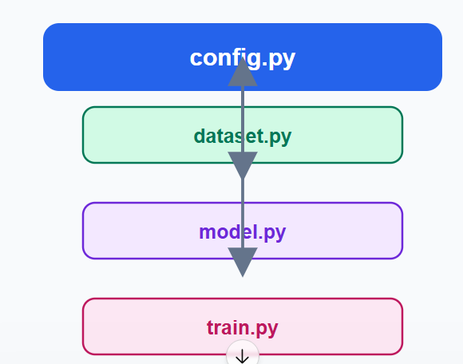

File 2 — src/transforms.py
This file handles image preprocessing.
from torchvision import transforms

train_transform = transforms.Compose([
transforms.ToTensor(),
transforms.Normalize((0.1307,), (0.3081,))
])

test_transform = transforms.Compose([
transforms.ToTensor(),
transforms.Normalize((0.1307,), (0.3081,))
])

transforms.py is the preprocessing pipeline. Its job is to convert raw images into the format that a neural network can learn from.
Single Responsibility: Transform images → Return tensors ready for the CNN.
Where it fits
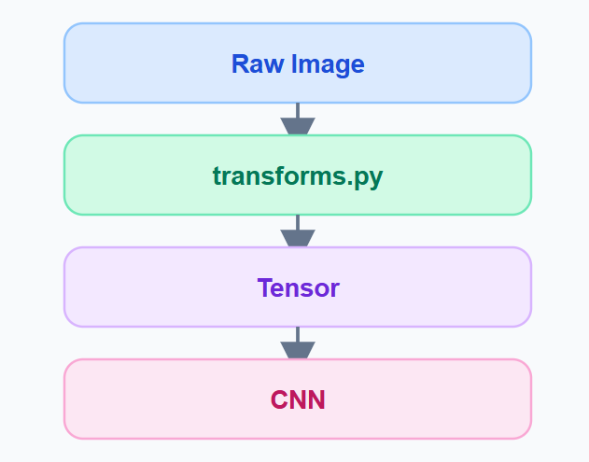
The CNN never receives raw images. It receives transformed tensors.

1. What is Compose()?
Compose means apply multiple transformations in sequence.
Instead of writing:
image = ToTensor(image)
image = Normalize(image)
we create one pipeline:
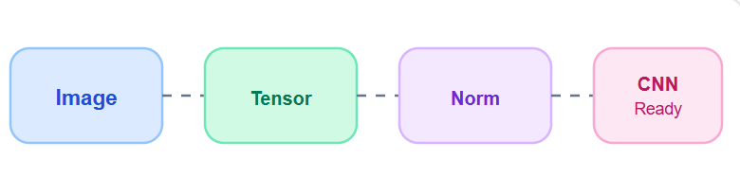

2. What does ToTensor() do?
The MNIST image starts as a PIL Image.
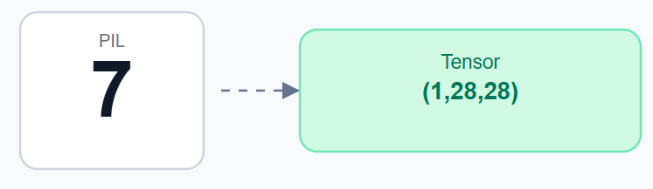
Before:
- Type = PIL Image
- Pixel = 0–255
After ToTensor():
- Type = Tensor
- Shape = (1,28,28)
- Pixels = 0.0–1.0
Example:
Original | Tensor
0 | 0.0
127 | 0.498
255 | 1.0
This conversion is essential because PyTorch models only work with tensors.

3. Why Normalize?
After ToTensor():
Pixels range from 0 to 1.
But neural networks train better when data is centered around zero.
The normalization formula is:
xnorm=x−meanstdx_{norm}=\frac{x-mean}{std}xnorm​=stdx−mean​
For MNIST:
Normalize((0.1307,), (0.3081,))
Where:
Value | Meaning
0.1307 | Dataset mean
0.3081 | Dataset standard deviation
These values were computed from all 60,000 MNIST images.

4. Visualizing Normalization
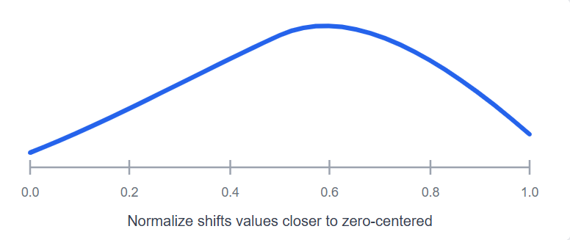
Instead of learning from raw brightness, the CNN learns from standardized values, making optimization more stable.

5. Why two transforms?
We created:
train_transform
and
test_transform
Right now they're identical.
Why separate them?
Because later we'll use augmentation only for training.
Training | Testing
Rotate | ❌
Flip | ❌
Crop | ❌
Normalize | ✅
ToTensor | ✅
Example for future projects:
train_transform = Compose([
RandomRotation(10),
RandomCrop(224),
ToTensor(),
Normalize(...)
])
Test images should never be randomly modified.

6. Order Matters
The sequence is important.
Correct:
Image
↓
ToTensor
↓
Normalize
↓
CNN
Incorrect:
Image
↓
Normalize ❌
↓
ToTensor
Normalize only works on tensors, so ToTensor() must come first.

7. Why is this file separate?
A common beginner mistake is putting transforms inside dataset.py.
Senior structure:
src/
├── transforms.py
├── dataset.py
└── model.py
Each file has one responsibility:
File | Responsibility
transforms.py | Image preprocessing
dataset.py | Load & split datasets
model.py | CNN architecture
This follows the Single Responsibility Principle, making the project easier to maintain and extend.

Key Takeaways
- Compose() builds a preprocessing pipeline.
- ToTensor() converts PIL images to PyTorch tensors and scales pixels to 0–1.
- Normalize() standardizes pixel values using the dataset's mean and standard deviation.
- We keep training and testing transforms separate because augmentation belongs only in training.

File 3 — src/dataset.py
This is the complete data loading pipeline.
import torch
from torch.utils.data import DataLoader, random_split
from torchvision.datasets import MNIST

from config import DATA_DIR, BATCH_SIZE, VALID_SPLIT, SEED
from transforms import train_transform, test_transform

def get_dataloaders():

# Training dataset
full_train = MNIST(
root=DATA_DIR,
train=True,
download=True,
transform=train_transform
)

# Test dataset
test_dataset = MNIST(
root=DATA_DIR,
train=False,
download=True,
transform=test_transform
)

# Train / Validation split
valid_size = int(len(full_train) * VALID_SPLIT)
train_size = len(full_train) - valid_size

generator = torch.Generator().manual_seed(SEED)

train_dataset, valid_dataset = random_split(
full_train,
[train_size, valid_size],
generator=generator
)

# DataLoaders
train_loader = DataLoader(
train_dataset,
batch_size=BATCH_SIZE,
shuffle=True,
num_workers=2,
pin_memory=True
)

valid_loader = DataLoader(
valid_dataset,
batch_size=BATCH_SIZE,
shuffle=False,
num_workers=2,
pin_memory=True
)

test_loader = DataLoader(
test_dataset,
batch_size=BATCH_SIZE,
shuffle=False,
num_workers=2,
pin_memory=True
)

return train_loader, valid_loader, test_loader

Section 1 — Imports
import torch
from torch.utils.data import DataLoader, random_split
from torchvision.datasets import MNIST
These imports are PyTorch utilities, not your own code.
Import | Job
torch | Core PyTorch library
MNIST | Downloads and reads MNIST
DataLoader | Creates mini-batches
random_split | Splits one dataset into two
Think of them like tools:
- MNIST = brings the data.
- random_split = divides the data.
- DataLoader = feeds the model.

Section 2 — Import Project Configuration
from .config import DATA_DIR, BATCH_SIZE, VALID_SPLIT, SEED
from .transforms import train_transform, test_transform
Notice the dot (.).
It means:
Import from the same src package.
Directory:
src/
├── config.py
├── transforms.py
└── dataset.py
This is called a relative import.

Section 3 — Why create a function?
def get_dataloaders():
Instead of executing immediately, we wrap everything inside a function.
Why?
Because later train.py simply does:
train_loader, val_loader, test_loader = get_dataloaders()
The training file doesn't need to know how the data was prepared.
This is abstraction.

Section 4 — Load the Training Dataset
full_train = MNIST(
root=DATA_DIR,
train=True,
download=True,
transform=train_transform
)

What each argument means
Argument | Meaning
root | Save location
train=True | Load training images
download=True | Download automatically
transform | Apply preprocessing
Result:
60,000 images
60,000 labels
Nothing has been split yet.

Section 5 — Load Test Dataset
test_dataset = MNIST(
train=False,
...
)
Now PyTorch loads:
10,000 test images
Important rule:
Never mix training and test data.
The test dataset stays untouched until final evaluation.

Section 6 — Validation Split
We calculate it dynamically.
valid_size = int(len(full_train) * VALID_SPLIT)
Let's compute it.
60000×0.10=600060000 \times 0.10 = 600060000×0.10=6000
Then:
train_size = 60000 - 6000
Result:
Dataset | Images
Train | 54,000
Validation | 6,000
Notice we never wrote 6000 manually.

Section 7 — Random Generator
generator = torch.Generator().manual_seed(SEED)
This guarantees the same split every run.
Without it:
Run 1
Image #52 → Validation

Run 2
Image #52 → Training
Bad for experiments.
With SEED=42:
The split is identical every time.
This is called reproducibility.

Section 8 — random_split()
train_dataset, valid_dataset = random_split(
full_train,
[train_size, valid_size],
generator=generator
)
Visual:

It doesn't duplicate images—it creates two subsets referencing the original dataset.
Memory efficient.

Section 9 — Create DataLoaders
This is the most important part.
train_loader = DataLoader(
train_dataset,
batch_size=BATCH_SIZE,
shuffle=True,
num_workers=0,
pin_memory=False
)

Every parameter explained
Parameter | Purpose
train_dataset | Source of images
batch_size=64 | 64 images at once
shuffle=True | Random order every epoch
num_workers=0 | Windows compatibility
pin_memory=False | CPU mode for now
For validation and testing:
shuffle=False
because evaluation must always be consistent.

Section 10 — Return
return train_loader, valid_loader, test_loader
Now any file can simply write:
train_loader, val_loader, test_loader = get_dataloaders()
and immediately receive ready-to-use mini-batches.

Dataset vs DataLoader
Dataset | DataLoader
Stores images | Creates batches
Returns one sample | Returns many samples
(image, label) | (64 images, 64 labels)
Indexable | Iterable
Example:
dataset[0]
Returns:
(Image, Label)
But:
next(iter(train_loader))
Returns:
64 Images
64 Labels
That distinction is one of the most important concepts in PyTorch.

Test the Pipeline(TEMPORARY FILE FOR TEXT ONLY)
from src.dataset import get_dataloaders

train_loader, valid_loader, test_loader = get_dataloaders()

images, labels = next(iter(train_loader))

print(f"Images Shape : {images.shape}")
print(f"Labels Shape : {labels.shape}")

print(f"Training Samples : {len(train_loader.dataset)}")
print(f"Validation Samples : {len(valid_loader.dataset)}")
print(f"Test Samples : {len(test_loader.dataset)}")

Expected Output
Images Shape : torch.Size([64, 1, 28, 28])
Labels Shape : torch.Size([64])

Training Samples : 54000
Validation Samples : 6000
Test Samples : 10000
This confirms:
- ✅ MNIST downloaded correctly
- ✅ Train/validation split works
- ✅ Batch size is 64
- ✅ Tensor shape is correct

Engineering Review (Why this is Senior-Level)
Practice | Included
Separate configuration | ✅
Modular transforms | ✅
Reproducible split | ✅
GPU-ready DataLoader | ✅
Train/Validation/Test separation | ✅
Reusable function | ✅

Step 06A: Exploratory Data Analysis (EDA)
Before training a CNN, a senior engineer inspects the data visually and statistically. Never assume the dataset is correct.
Goal: Understand what the model will learn from.

What is EDA in Computer Vision?
EDA (Exploratory Data Analysis) answers questions like:
- Are the images loading correctly?
- Are the labels correct?
- Is the dataset balanced?
- What is the image size?
- Are there noisy or unusual samples?
For image datasets, EDA is mostly visual.

1. EDA Workflow
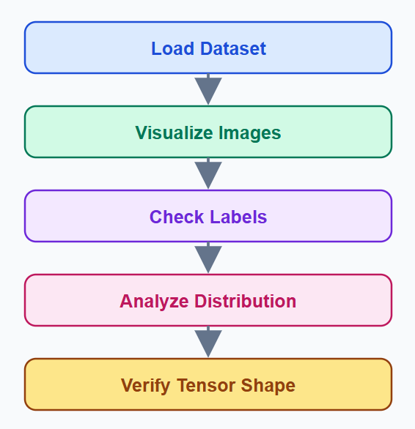
This is the standard CV inspection pipeline.

2. Visual Inspection
We begin by looking at random samples.
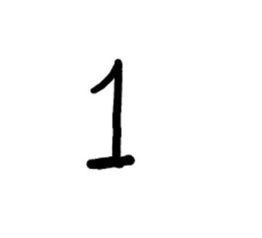
Immediately verify:
- Digits are readable
- Background is black
- Digits are centered
- No corrupted images
If images look wrong, never continue training.

3. Label Verification
Each image must match its label.
Image | Label
Handwritten 7 | 7
Handwritten 2 | 2
Handwritten 9 | 9
Handwritten 0 | 0
A wrong label teaches the CNN incorrect patterns.

4. Image Properties
Every MNIST sample should have identical dimensions.
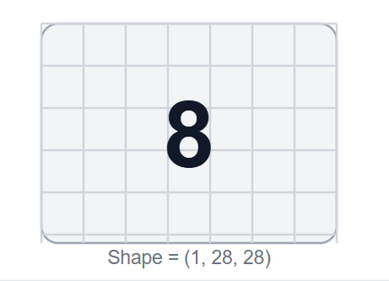
Expected properties:
Property | Value
Width | 28 px
Height | 28 px
Channels | 1
Tensor Shape | (1,28,28)

5. Pixel Distribution
Original pixel values range from 0–255.
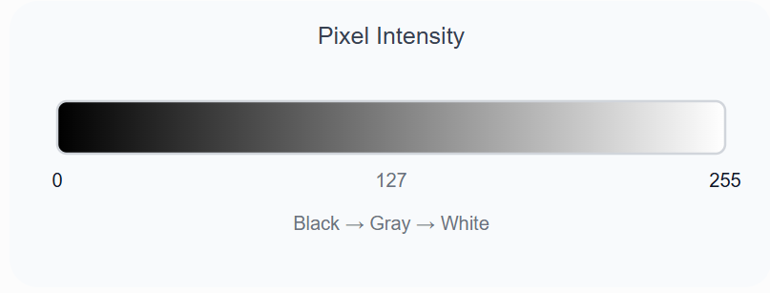
After ToTensor():
0 → 0.0 255 → 1.00
After normalization, values become centered around zero.

6. Class Distribution
MNIST is nearly balanced.
Training images per class
MNIST has a nearly balanced class distribution.
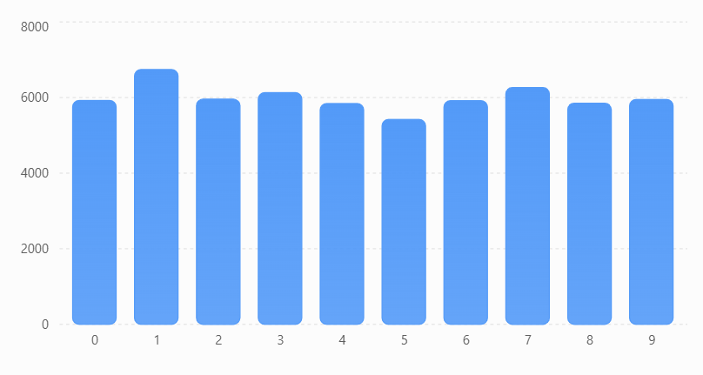
Observation:
- No severe imbalance
- No oversampling needed
- Accuracy is a meaningful metric
Later medical datasets will require different strategies.

7. Tensor Shape Check
One batch from the DataLoader should look like this:
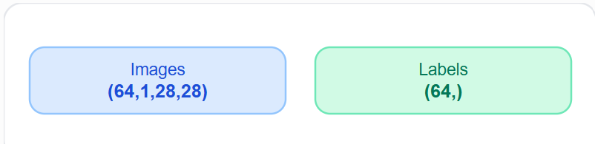
Interpretation:
Dimension | Meaning
64 | Batch size
1 | Grayscale
28 | Height
28 | Width
This confirms the pipeline is correct before training.

8. Data Quality Checklist
A senior engineer verifies these before moving forward.
Check | Expected
Images load | ✅
Labels correct | ✅
Shape = (1,28,28) | ✅
10 classes | ✅
Balanced distribution | ✅
No corrupted samples | ✅
If any check fails, fix the data pipeline first.

Step 06B: EDA Implementation
Now we write the actual EDA code. This is the first visualization module in your deep learning project.
Goal: Inspect the MNIST dataset before training.

1. Create a new file
Create this file:
src/eda.py
Updated structure:
src/
├── config.py
├── transforms.py
├── dataset.py
├── eda.py ← NEW
├── model.py
└── ...

2. Complete eda.py
Write this code exactly.
import matplotlib.pyplot as plt
import torch
from collections import Counter

from .dataset import get_dataloaders

def show_random_samples():
train_loader, _, _ = get_dataloaders()

images, labels = next(iter(train_loader))

fig, axes = plt.subplots(2, 5, figsize=(10, 4))
axes = axes.flatten()

for i in range(10):
img = images[i].squeeze()
axes[i].imshow(img, cmap="gray")
axes[i].set_title(f"Label: {labels[i].item()}")
axes[i].axis("off")

plt.tight_layout()
plt.show()

def class_distribution():
train_loader, _, _ = get_dataloaders()

all_labels = []

for _, labels in train_loader:
all_labels.extend(labels.tolist())

counts = Counter(all_labels)

plt.figure(figsize=(8, 4))
plt.bar(counts.keys(), counts.values())
plt.title("MNIST Class Distribution")
plt.xlabel("Digit")
plt.ylabel("Number of Images")
plt.xticks(range(10))
plt.show()

def tensor_information():
train_loader, _, _ = get_dataloaders()

images, labels = next(iter(train_loader))

print("=" * 40)
print("Tensor Information")
print("=" * 40)
print(f"Images Shape : {images.shape}")
print(f"Labels Shape : {labels.shape}")
print(f"Image dtype : {images.dtype}")
print(f"Min Pixel : {images.min():.3f}")
print(f"Max Pixel : {images.max():.3f}")
print("=" * 40)

if __name__ == "__main__":
tensor_information()
show_random_samples()
class_distribution()

Correct way to run each file
File | Run? | Command
config.py | ❌ No | Don't run
transforms.py | ❌ No | Don't run
dataset.py | ❌ No | Imported by other files
test_loader.py | ✅ Yes | python test_loader.py
eda.py | ✅ Yes | python -m src.eda

3. What each function does

A. tensor_information()
This verifies your pipeline.
images, labels = next(iter(train_loader))
Expected output:
========================================
Tensor Information
========================================
Images Shape : torch.Size([64, 1, 28, 28])
Labels Shape : torch.Size([64])
Image dtype : torch.float32
Min Pixel : -0.424
Max Pixel : 2.821
========================================

Why are pixels not 0–1?
Because we already applied:
Normalize((0.1307,), (0.3081,))
Normalization changes the range.

B. show_random_samples()
This displays 10 random training images.
Expected result:
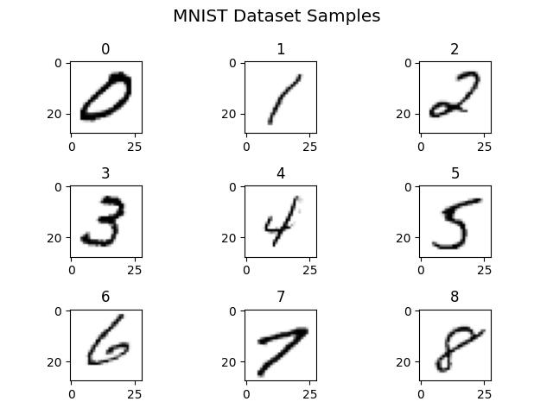
Each image should display its label.
This is your first visual quality check.

C. class_distribution()
This counts every label using:
Counter(all_labels)
Expected graph:
MNIST class distribution
Counts collected from the training DataLoader.
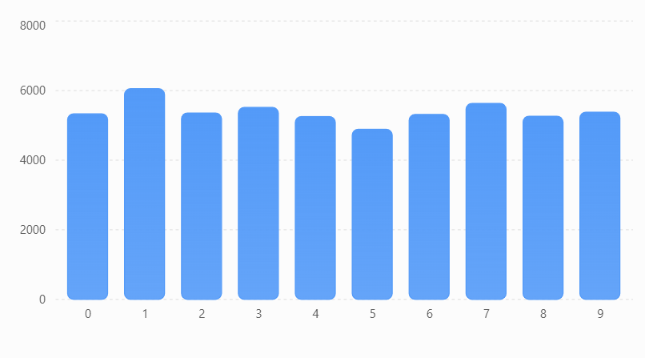Your numbers may vary slightly because the validation split is random, but they'll be close.

4. How to run
From the project root:
python -m src.eda
Don't run:
python src/eda.py
Why?
Because we're using relative imports (from .dataset), so the module should be executed with -m.

5. What files are created?
At this stage, nothing is saved yet.
The functions currently display:
- Tensor information
- Random samples
- Class distribution
In the next improvement, we'll save them into:
outputs/
└── plots/
├── sample_images.png
└── class_distribution.png
This is the professional workflow.

6. What you learned
Concept | Purpose
next(iter(loader)) | Get one batch
.squeeze() | Remove channel dimension for plotting
imshow() | Display images
Counter() | Count class frequencies
matplotlib | Visualize the dataset

Step 07A: Build the CNN Architecture
Now we build the brain of the AI: the Convolutional Neural Network.
This is the most important step in Project 1 because you'll understand how images become predictions.
Goal: Design a CNN that classifies handwritten digits (0–9).

1. The complete CNN pipeline
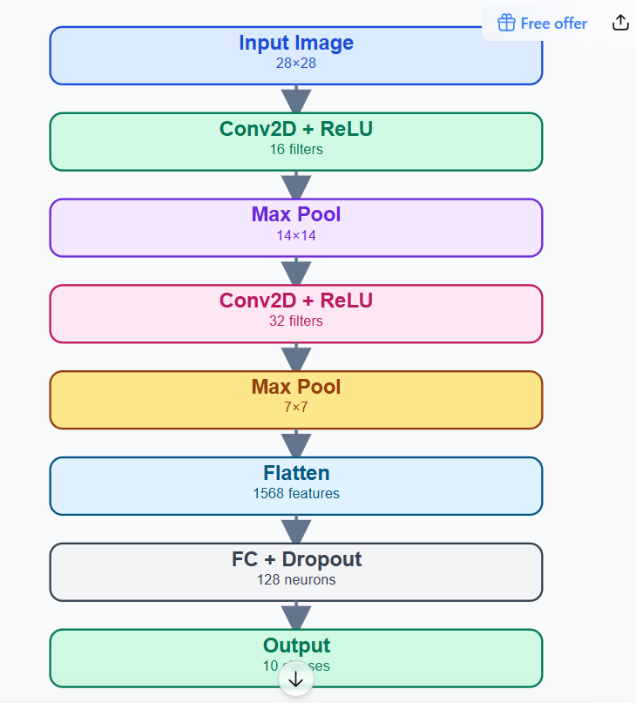
This exact architecture is used in thousands of beginner-to-intermediate vision projects.

2. Input tensor
The DataLoader gives us:
(64,1,28,28)
Meaning:
Dimension | Value
Batch | 64
Channels | 1
Height | 28
Width | 28
The CNN processes one batch at a time.

3. First Convolution Layer
A convolution is not looking at the whole image.
It scans small windows called kernels.
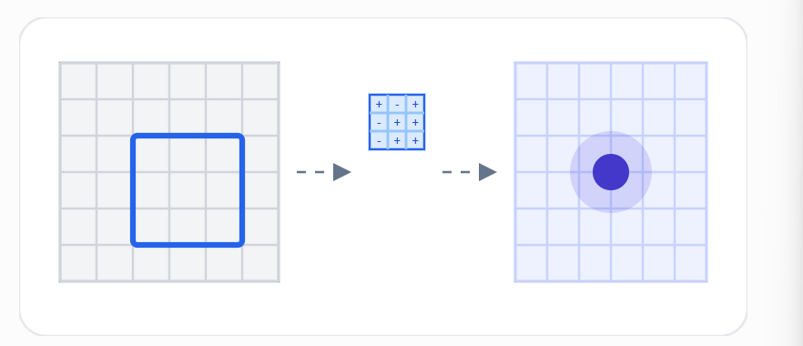
Instead of memorizing pixels, the kernel learns:
- Edges
- Curves
- Corners
- Strokes
For MNIST, this is exactly what handwritten digits are made of.

4. Why 16 filters?
Our first layer uses:
Conv2D(1→16)Conv2D
That means:
- Input channel = 1
- Output feature maps = 16
Visualization:
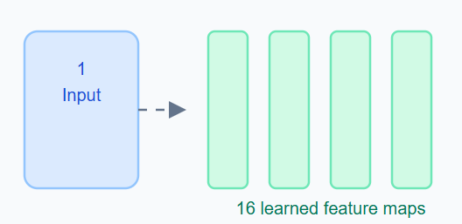
Each filter learns a different visual pattern.
Examples:
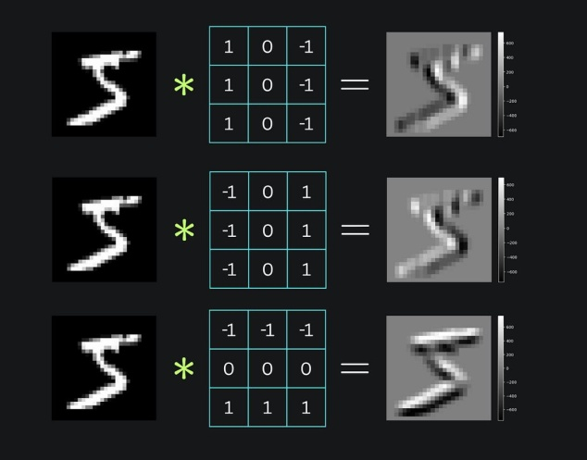
Edges
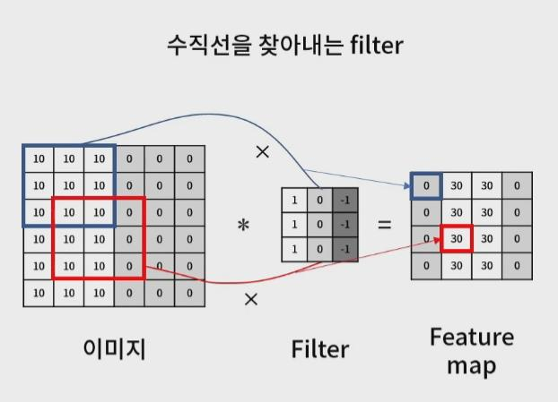
Vertical
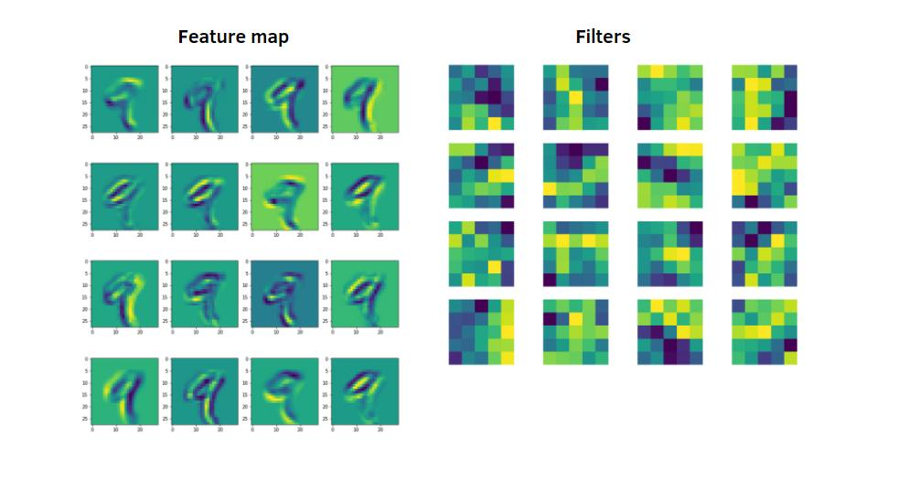
Curves
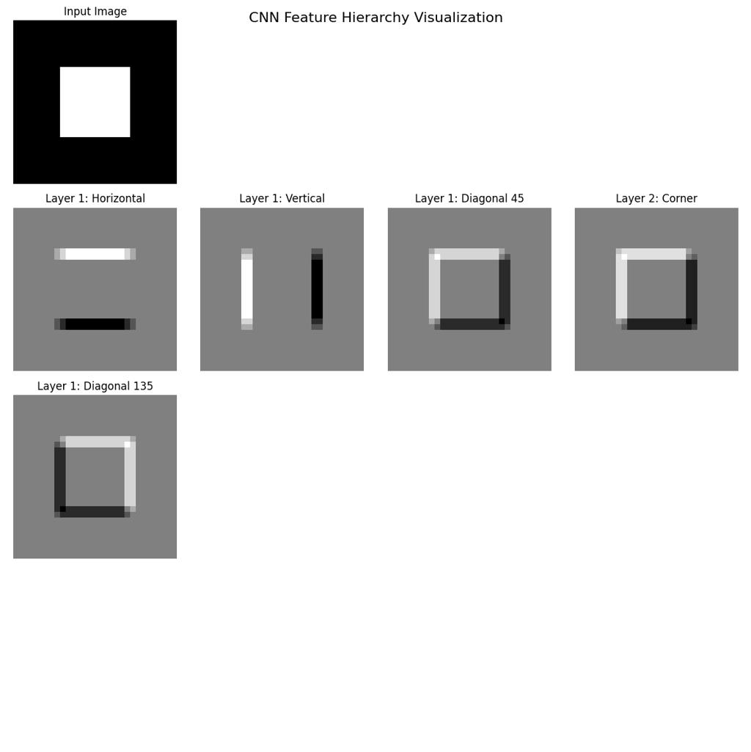
Corners
The CNN discovers these automatically during training.

5. ReLU Activation
After convolution:
y=max⁡(0,x)
Graphically:
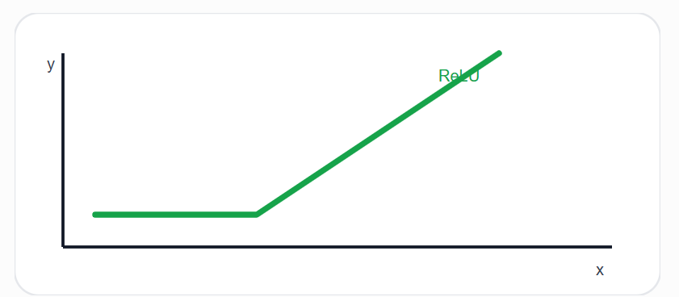
Negative values become zero.
Why?
- Adds non-linearity
- Helps the network learn complex shapes
- Prevents linear behavior
Without ReLU, stacking many layers is almost useless.

6. Max Pooling
Pooling reduces image size.
Before:
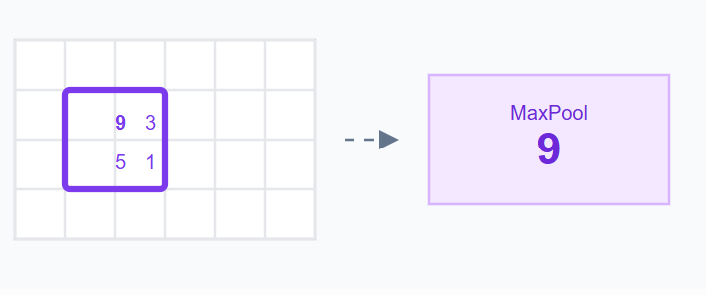
The maximum value survives.
This gives:
- Smaller tensors
- Faster computation
- Better feature extraction
Shape change:
28×28→14×14

7. Second Convolution
Now we increase depth.
16→32
Why?
The first layer learns simple features.
The second layer combines them into:
- Loops
- Crossings
- Digit shapes
Hierarchy:
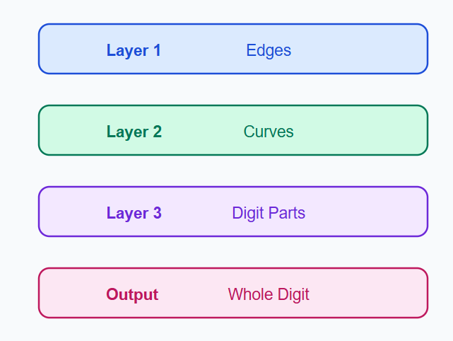
Deep learning works because features become increasingly abstract.

8. Flatten Layer
After pooling:
(32,7,7)
A fully connected layer needs a vector, not a cube.
So:
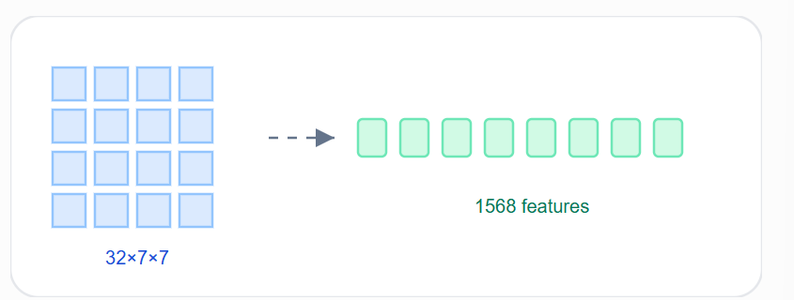 Visualization:

This operation does not lose information—it only changes shape.

9. Fully Connected Layer
Now the network performs classification.
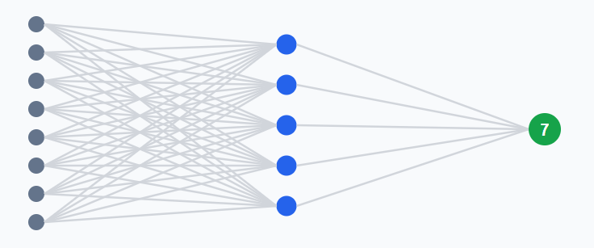
We reduce:
1568→128→10
Final output:
Neuron | Digit
0 | 0
1 | 1
... | ...
9 | 9
The neuron with the highest score becomes the prediction.

10. Why Dropout?
During training:

Dropout randomly disables neurons.
Benefits:
- Reduces overfitting
- Improves generalization
- Makes the model more robust
For MNIST we'll use:
p=0.5
Meaning 50% of neurons are temporarily ignored during training.

Final Architecture Summary
Layer | Output Shape
Input | (1,28,28)
Conv1 | (16,28,28)
MaxPool | (16,14,14)
Conv2 | (32,14,14)
MaxPool | (32,7,7)
Flatten | 1568
FC1 | 128
Dropout | 128
FC2 | 10

Step 07B: Implement the CNN (model.py)
Now we convert the architecture into professional PyTorch code.
Goal: Create a reusable CNN model that outputs predictions for 10 digits.

1. Create src/model.py
Your src folder now becomes:
src/
├── config.py
├── transforms.py
├── dataset.py
├── eda.py
├── model.py ← NEW
├── engine.py
├── train.py
└── ...

2. Complete model.py
Write this code exactly:
import torch
import torch.nn as nn

class DigitCNN(nn.Module):

def __init__(self):
super().__init__()

self.features = nn.Sequential(

nn.Conv2d(
in_channels=1,
out_channels=16,
kernel_size=3,
padding=1
),

nn.ReLU(),

nn.MaxPool2d(kernel_size=2),

nn.Conv2d(
in_channels=16,
out_channels=32,
kernel_size=3,
padding=1
),

nn.ReLU(),

nn.MaxPool2d(kernel_size=2)
)

self.classifier = nn.Sequential(

nn.Flatten(),

nn.Linear(32 * 7 * 7, 128),

nn.ReLU(),

nn.Dropout(0.5),

nn.Linear(128, 10)
)

def forward(self, x):

x = self.features(x)

x = self.classifier(x)

return x

This is a modular CNN. We separated:
- Feature extractor
- Classifier
Exactly like larger models (ResNet, EfficientNet).

3. Understanding nn.Module
Every PyTorch model inherits from:
class DigitCNN(nn.Module):
nn.Module gives your model:
- Trainable parameters
- GPU support
- .train()
- .eval()
- .state_dict()
Think of it as the base class for every neural network.

4. Why super().__init__()?
super().__init__()
This initializes the parent nn.Module.
Without it, PyTorch cannot register your layers.
Always the first line inside __init__.

5. Feature Extractor
self.features = nn.Sequential(...)
Instead of writing layers separately:
self.conv1
self.relu1
self.pool1
we group them into one block.
Flow:
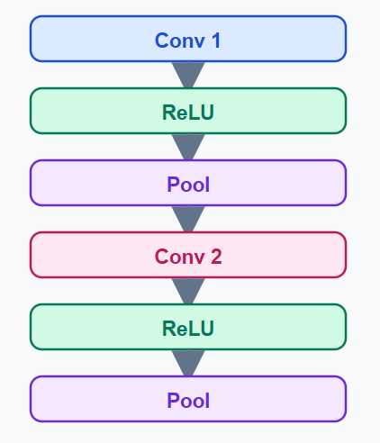
This block learns visual features.

6. Conv2D Deep Dive
nn.Conv2d(
in_channels=1,
out_channels=16,
kernel_size=3,
padding=1
)

What each parameter means
Parameter | Value | Meaning
in_channels | 1 | Grayscale input
out_channels | 16 | 16 feature maps
kernel_size | 3 | 3×3 filter
padding | 1 | Preserve image size

Why padding = 1?
Without padding:
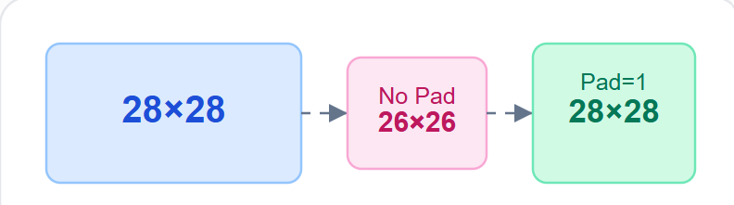
With padding=1, height and width stay the same.
Formula:

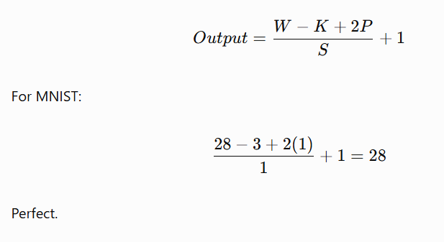

7. MaxPool Layer
nn.MaxPool2d(kernel_size=2)
It halves the spatial dimensions.
28×28 → 14×14
After the second pooling:
14×14→7×7

8. Classifier Block
self.classifier = nn.Sequential(...)
This converts features into class scores.
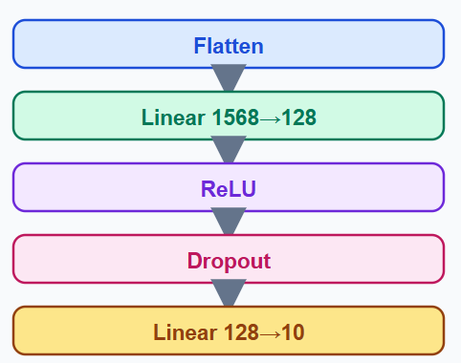
The classifier performs the final decision making.

9. Why 1568?
Before flatten:
(32,7,7)
Flatten multiplies everything:
32×7×7=1568
That becomes the input to the first linear layer.

10. Forward Pass
This is the most important function.
def forward(self, x):

x = self.features(x)

x = self.classifier(x)

return x
The forward method defines how data flows.
Input:
(64,1,28,28)
Output:
(64,10)
Meaning:
- 64 predictions
- 10 scores for each image

11. Test the Model
Create a temporary file:
test_model.py
import torch

from src.model import DigitCNN

model = DigitCNN()

x = torch.randn(64, 1, 28, 28)

output = model(x)

print("Input Shape :", x.shape)
print("Output Shape:", output.shape)
Run:
python test_model.py
Expected output:

Input Shape : torch.Size([64, 1, 28, 28])
Output Shape: torch.Size([64, 10])

This proves your CNN architecture is correct.

Step 07 Complete
You now have a complete feature extractor + classifier.
Component | Status
Conv2D | ✅
ReLU | ✅
MaxPool | ✅
Flatten | ✅
Linear | ✅
Dropout | ✅
Forward Pass | ✅
The next step is Step 08: Training Pipeline (engine.py), where we'll implement the loss function, optimizer, forward pass, backpropagation, and parameter updates.

Step 08A: Training Pipeline
You now have data and a CNN model. The next step is teaching the model how to learn.
Goal: Build the training engine that updates the CNN's weights using backpropagation.

The complete training pipeline
This is what happens during one epoch.
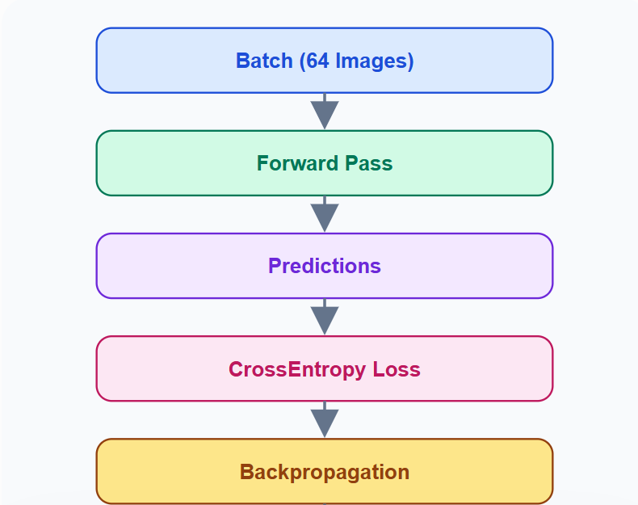
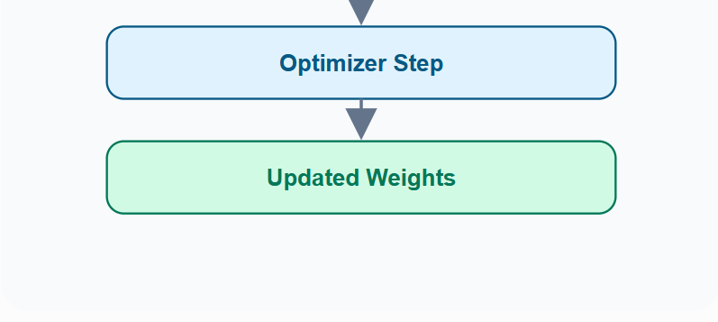
This loop repeats 844 times for one epoch.

1. What is an Epoch?
Your training set contains:
54,000 images54,000\text{ images}54,000 images
Batch size:
646464
Therefore:
5400064=844 batches
Term | Meaning
Image | One sample
Batch | 64 images
Epoch | All 54,000 images once
If you train for 10 epochs, the model sees the dataset 10 times.

2. Forward Pass
The first learning step is:
Prediction=Model(Image)
Example:
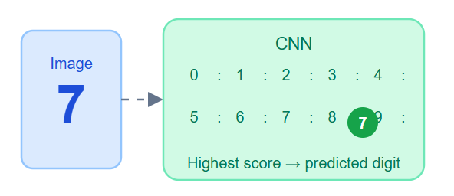
The CNN outputs 10 scores, not the digit directly.

3. Cross Entropy Loss
The true label is:
7
Suppose predictions are:
Digit | Score
0 | 0.01
1 | 0.02
2 | 0.03
... | ...
7 | 0.91
8 | 0.01
Loss becomes small because prediction is correct.
If the model predicts 3 instead:
Digit | Score
3 | 0.88
7 | 0.04
Loss becomes large.
The objective is simple:
Minimize the loss.

4. Backpropagation
This is the learning mechanism.
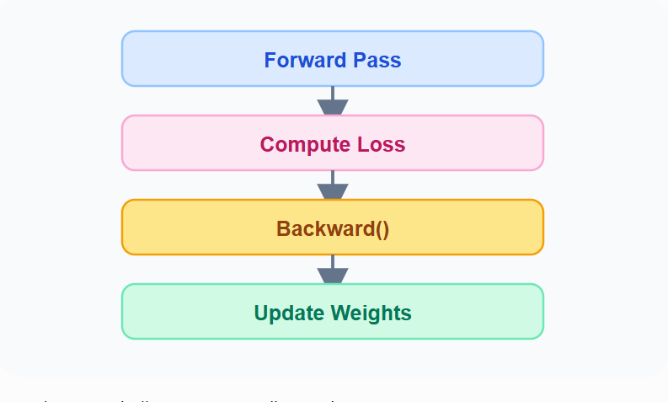
PyTorch automatically computes gradients using:
loss.backward()
You never calculate derivatives manually.

5. The Optimizer
The optimizer updates parameters.
For this project:
Adam(lr=0.001)
Think of it as:
The optimizer is the teacher correcting the CNN after every mistake.

6. Learning Rate
The learning rate controls how big each update is.
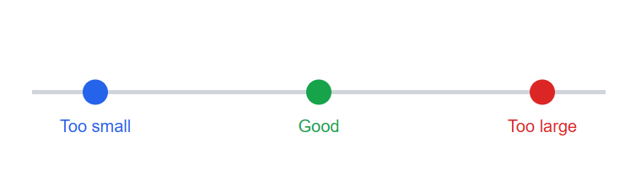
LR | Effect
0.1 | Unstable
0.01 | Fast
0.001 | Standard
0.0001 | Slow
We'll use 0.001.

7. Train vs Eval Mode
PyTorch has two modes.
Mode | Purpose
model.train() | Training
model.eval() | Validation/Test
Why?
Because Dropout behaves differently.
During training:
- Random neurons are dropped.
During evaluation:
- All neurons are active.
This is why switching modes is mandatory.

8. Training Loop Logic
This is the algorithm we'll implement in engine.py.

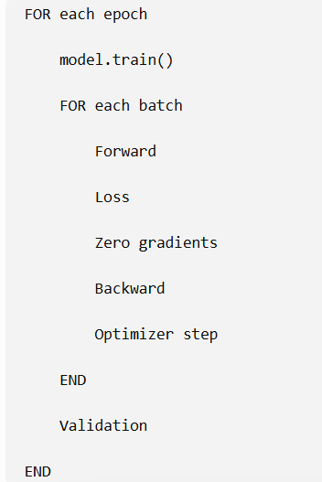
This structure will remain almost identical for ResNet, EfficientNet, and Vision Transformers.

Files for Step 08
We will create:
src/
├── engine.py
└── train.py
Responsibilities:
File | Job
engine.py | Training & validation functions
train.py | Main program

Step 08B: Implement the Training Engine
This is where your CNN actually learns. We'll build engine.py, which contains the training and validation logic.
Goal: Create reusable training functions that can be used in every future project (ResNet, EfficientNet, etc.).

1. Create src/engine.py
src/
├── model.py
├── dataset.py
├── engine.py ← NEW
└── train.py

2. Complete engine.py
import torch
from tqdm import tqdm

def train_one_epoch(model, loader, criterion, optimizer, device):

model.train()

running_loss = 0
correct = 0
total = 0

progress = tqdm(loader, desc="Training", leave=False)

for images, labels in progress:

images = images.to(device)
labels = labels.to(device)

optimizer.zero_grad()

outputs = model(images)

loss = criterion(outputs, labels)

loss.backward()

optimizer.step()

running_loss += loss.item()

_, predicted = torch.max(outputs, 1)

total += labels.size(0)
correct += (predicted == labels).sum().item()

progress.set_postfix(
loss=f"{loss.item():.4f}",
acc=f"{100*correct/total:.2f}%"
)

epoch_loss = running_loss / len(loader)
epoch_acc = 100 * correct / total

return epoch_loss, epoch_acc

def validate(model, loader, criterion, device):

model.eval()

running_loss = 0
correct = 0
total = 0

with torch.no_grad():

for images, labels in loader:

images = images.to(device)
labels = labels.to(device)

outputs = model(images)

loss = criterion(outputs, labels)

running_loss += loss.item()

_, predicted = torch.max(outputs, 1)

total += labels.size(0)
correct += (predicted == labels).sum().item()

val_loss = running_loss / len(loader)
val_acc = 100 * correct / total

return val_loss, val_acc
This file contains two reusable functions:
- train_one_epoch()
- validate()

3. Why two functions?
A senior project separates training from validation.
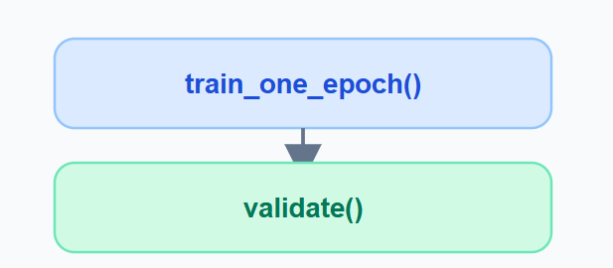
train.py will simply call both every epoch.

4. Training Mode
model.train()
This tells PyTorch:
- Enable Dropout
- Enable BatchNorm updates
- Prepare for learning
Always call this before training.

5. Move data to GPU
images = images.to(device)
labels = labels.to(device)
Without this:
- Images stay on CPU
- Model is on GPU
- PyTorch throws a device mismatch error
Everything must live on the same device.

6. Why optimizer.zero_grad()?
Gradients accumulate by default.
Bad:
Batch 1
Gradient = 0.5

Batch 2
Gradient = 1.2 ❌ Added together
Good:
optimizer.zero_grad()
Now every batch starts fresh.

7. Forward Pass
outputs = model(images)
Shape:
Tensor | Shape
Images | (64,1,28,28)
Outputs | (64,10)
Each image produces 10 class scores.

8. Compute Loss
loss = criterion(outputs, labels)
We'll use CrossEntropyLoss.
Example:
Prediction | True | Loss
7 | 7 | Low
3 | 7 | High
The optimizer tries to reduce this value.

9. Backpropagation
loss.backward()
This computes gradients for every weight in the CNN.
Think of it as asking:
Which weights caused the mistake?
PyTorch answers automatically.

10. Update Weights
optimizer.step()
This is the actual learning step.
Formula:
Wnew=Wold−lr×gradientW_{new}=W_{old}-lr\times gradientWnew​=Wold​−lr×gradient
The model becomes slightly better after every batch.

11. Accuracy Calculation
_, predicted = torch.max(outputs, 1)
Example output:
Scores | Prediction
[0.1,0.2,0.8,...] | 2
Then:
correct += (predicted == labels).sum().item()
Counts correct predictions.
Accuracy:
Accuracy=CorrectTotal×100

12. Validation
Notice two differences:
model.eval()
and
with torch.no_grad():
Why?
torch.no_grad():
- Saves memory
- Faster inference
- No gradients computed
Validation should never update weights.

13. Return Values
Both functions return:
loss, accuracy
Example:
Train Loss : 0.1842
Train Acc : 94.82%

Val Loss : 0.0915
Val Acc : 97.31%
These values will later be plotted into learning curves.

Engineering Summary
Function | Responsibility
model.train() | Enable training mode
zero_grad() | Clear old gradients
model(images) | Forward pass
criterion() | Compute loss
backward() | Compute gradients
step() | Update weights
model.eval() | Evaluation mode
torch.no_grad() | Disable gradient tracking

Step 09: Main Training Script (train.py)
This is the main program of your deep learning project. It connects every module you've built:
- config.py
- dataset.py
- model.py
- engine.py
When you run one command, the entire CNN training starts.

1. Architecture of train.py
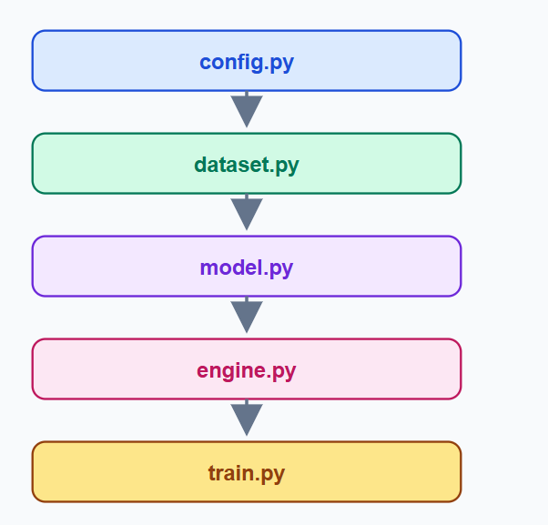
Everything flows into train.py.

2. Update config.py
Add these training hyperparameters:
# ==========================
# Training Hyperparameters
# ==========================
EPOCHS = 10
LEARNING_RATE = 0.001

Your config now controls the entire experiment.

3. Create src/train.py
Write this complete code:
import torch
import torch.nn as nn

from .config import (
DEVICE,
EPOCHS,
LEARNING_RATE,
CHECKPOINT_DIR
)

from .dataset import get_dataloaders
from .model import DigitCNN
from .engine import train_one_epoch, validate

def main():

train_loader, val_loader, test_loader = get_dataloaders()

model = DigitCNN().to(DEVICE)

criterion = nn.CrossEntropyLoss()

optimizer = torch.optim.Adam(
model.parameters(),
lr=LEARNING_RATE
)

best_accuracy = 0

print("=" * 55)
print("MNIST CNN TRAINING STARTED")
print("=" * 55)

for epoch in range(EPOCHS):

train_loss, train_acc = train_one_epoch(
model,
train_loader,
criterion,
optimizer,
DEVICE
)

val_loss, val_acc = validate(
model,
val_loader,
criterion,
DEVICE
)

print(
f"Epoch {epoch+1}/{EPOCHS} | "
f"Train Loss: {train_loss:.4f} | "
f"Train Acc: {train_acc:.2f}% | "
f"Val Loss: {val_loss:.4f} | "
f"Val Acc: {val_acc:.2f}%"
)

if val_acc > best_accuracy:

best_accuracy = val_acc

torch.save(
model.state_dict(),
CHECKPOINT_DIR / "best_model.pth"
)

print(f"Best Model Saved ({val_acc:.2f}%)")

print("=" * 55)
print("TRAINING FINISHED")
print(f"Best Validation Accuracy: {best_accuracy:.2f}%")
print("=" * 55)

if __name__ == "__main__":
main()

4. Understanding each section

Load Data
train_loader, val_loader, test_loader = get_dataloaders()
This imports the pipeline you already built.
Returns:
- Train loader
- Validation loader
- Test loader
No duplicated code.

Create Model
model = DigitCNN().to(DEVICE)
Two things happen:
- CNN is created
- Model moves to GPU (or CPU)
On your RTX 3070:
DEVICE = cuda

Loss Function
criterion = nn.CrossEntropyLoss()
Why CrossEntropy?
Because MNIST is a 10-class classification problem.
Output:
(64,10)(64,10)(64,10)
Labels:
(64,)(64,)(64,)
CrossEntropy compares them automatically.

Optimizer
optimizer = torch.optim.Adam(
model.parameters(),
lr=LEARNING_RATE
)
We're telling Adam:
- Update every trainable weight
- Use learning rate = 0.001

Epoch Loop
for epoch in range(EPOCHS):
If EPOCHS = 10:
Epoch 1
Epoch 2
...
Epoch 10
Each epoch processes all 54,000 training images.

Best Model Saving
if val_acc > best_accuracy:
This is critical.
We do not save every epoch.
We only save the model with the highest validation accuracy.
Result:
checkpoints/
└── best_model.pth
This is the model you'll deploy later.

5. Expected Terminal Output
When you run training:
=======================================================
MNIST CNN TRAINING STARTED
=======================================================

Epoch 1/10
Train Loss: 0.2841
Train Acc : 91.42%
Val Loss : 0.1028
Val Acc : 97.10%

Best Model Saved (97.10%)

Epoch 2/10
Train Loss: 0.0892
Train Acc : 97.35%
Val Acc : 98.21%

Best Model Saved (98.21%)

...

TRAINING FINISHED
Best Validation Accuracy: 99.02%

6. How to Run
From the project root:
python -m src.train
Do not run:
python src/train.py
Because we're using relative imports.

7. Files Created Automatically
After training:
checkpoints/
└── best_model.pth
This file contains the learned CNN weights.

Project Progress
Step | Status
Project Definition | ✅
Dataset Study | ✅
Architecture | ✅
Environment | ✅
Data Loading | ✅
EDA | ✅
CNN Model | ✅
Training Engine | ✅
Main Training | ✅
Evaluation | ⏳ Next
How the model learn.
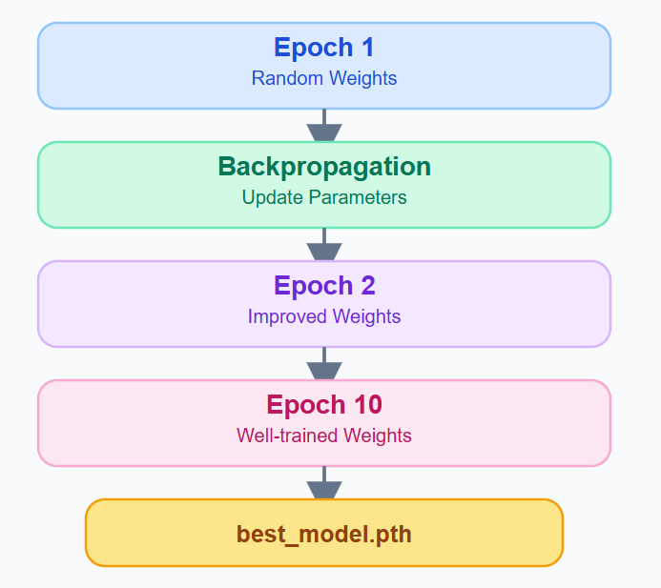

What happens during Epoch 1?
Suppose the image is 7.
The model predicts:
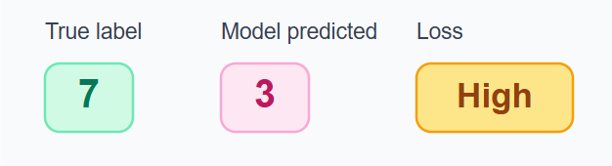
The loss is high.
Then:
loss.backward()
optimizer.step()
The optimizer slightly changes the weights.
Example:
Weight | Before | After
W₁ | 0.18 | 0.22
W₂ | -0.42 | -0.38
W₃ | 0.09 | 0.11
The model has now learned a tiny amount.

Step 10: Evaluation System
A senior deep learning engineer never reports only accuracy. We evaluate the model using multiple metrics and analyze its mistakes.

What we will build
src/
├── evaluate.py ← NEW
Outputs:
outputs/
├── confusion_matrix.png
├── metrics.json
└── classification_report.txt

1. Evaluation Pipeline
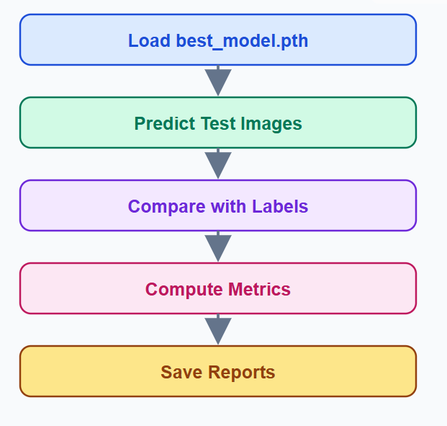
This uses the saved model, not the training model.

2. Why do we use the Test Set?
Remember your data split:


Dataset | Purpose
Train | Learn
Validation | Choose best model
Test | Final evaluation
The test set has never been used for learning.

3. Metrics We Will Calculate
Metric | Meaning
Accuracy | Overall correctness
Precision | How many predicted digits are correct
Recall | How many true digits were found
F1 Score | Balance of precision & recall
Confusion Matrix | Which digits are confused
These are the standard metrics for classification.

4. Confusion Matrix
Suppose the model predicts these digits:
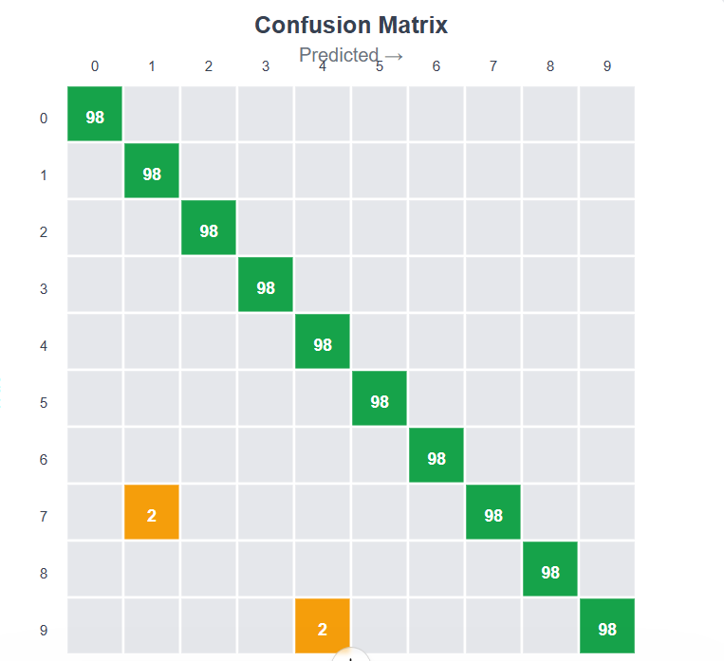
Interpretation:
- Green diagonal = Correct predictions
- Orange cells = Mistakes
Example:
- True 7 predicted as 1
- True 9 predicted as 4
This tells us where the model struggles.

5. Precision vs Recall
Imagine only digit 8.
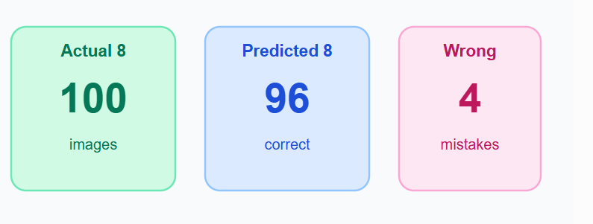
Precision asks:
Of everything I called 8, how many were really 8?
Recall asks:
Of all real 8s, how many did I find?
F1 combines both.

6. What files will be created?
After evaluation:
outputs/
├── metrics.json
├── confusion_matrix.png
└── classification_report.txt
Example metrics:
{
"accuracy": 98.95,
"precision": 98.96,
"recall": 98.94,
"f1_score": 98.95
}
This is what employers expect in a professional repository.

Step 10A Summary
We are not coding yet—this is the design phase.
We defined:
- Test evaluation
- Confusion matrix
- Precision
- Recall
- F1-score
- Output artifacts

Step 10B: Implement evaluate.py
Now we build the evaluation system that loads the trained model and measures its performance on the 10,000 unseen test images.
Goal: Generate professional evaluation artifacts:
- metrics.json
- classification_report.txt
- confusion_matrix.png

1. Install one package
We'll use scikit-learn for metrics.
pip install scikit-learn

2. Create src/evaluate.py
import json
import matplotlib.pyplot as plt
import seaborn as sns
import torch

from sklearn.metrics import (
accuracy_score,
precision_score,
recall_score,
f1_score,
confusion_matrix,
classification_report,
)

from .config import DEVICE, CHECKPOINT_DIR, OUTPUT_DIR
from .dataset import get_dataloaders
from .model import DigitCNN

def evaluate():

_, _, test_loader = get_dataloaders()

model = DigitCNN().to(DEVICE)

model.load_state_dict(
torch.load(
CHECKPOINT_DIR / "best_model.pth",
map_location=DEVICE
)
)

model.eval()

all_labels = []
all_predictions = []

with torch.no_grad():

for images, labels in test_loader:

images = images.to(DEVICE)

outputs = model(images)

_, predicted = torch.max(outputs, 1)

all_labels.extend(labels.numpy())
all_predictions.extend(predicted.cpu().numpy())

accuracy = accuracy_score(all_labels, all_predictions)
precision = precision_score(all_labels, all_predictions, average="macro")
recall = recall_score(all_labels, all_predictions, average="macro")
f1 = f1_score(all_labels, all_predictions, average="macro")

metrics = {
"accuracy": round(accuracy * 100, 2),
"precision": round(precision * 100, 2),
"recall": round(recall * 100, 2),
"f1_score": round(f1 * 100, 2)
}

with open(OUTPUT_DIR / "metrics.json", "w") as f:
json.dump(metrics, f, indent=4)

report = classification_report(all_labels, all_predictions)

with open(OUTPUT_DIR / "classification_report.txt", "w") as f:
f.write(report)

cm = confusion_matrix(all_labels, all_predictions)

plt.figure(figsize=(8, 6))

sns.heatmap(
cm,
annot=True,
fmt="d",
cmap="Blues"
)

plt.title("MNIST Confusion Matrix")
plt.xlabel("Predicted")
plt.ylabel("True")

plt.savefig(
OUTPUT_DIR / "confusion_matrix.png",
dpi=300,
bbox_inches="tight"
)

plt.close()

print("=" * 50)
print("Evaluation Completed")
print(metrics)
print("=" * 50)

if __name__ == "__main__":
evaluate()

3. Understanding the code

Step A — Load the trained model
model.load_state_dict(...)
This is where your learned weights return.
Think of it as:
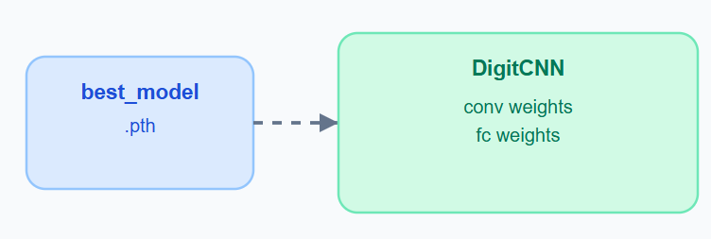
The architecture comes from DigitCNN().
The knowledge comes from best_model.pth.

Step B — Prediction
outputs = model(images)
Example:
True | Predicted
7 | 7
3 | 3
9 | 4 ❌
We collect both arrays.

Step C — Metrics
accuracy_score(...)
This compares:
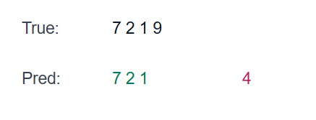
Accuracy counts how many are equal.

Step D — Save JSON
The metrics become:
{
"accuracy": 98.95,
"precision": 98.96,
"recall": 98.94,
"f1_score": 98.95
}
This is useful for dashboards and future experiments.

Step E — Confusion Matrix
The matrix is computed by:
cm = confusion_matrix(...)
Then visualized as:
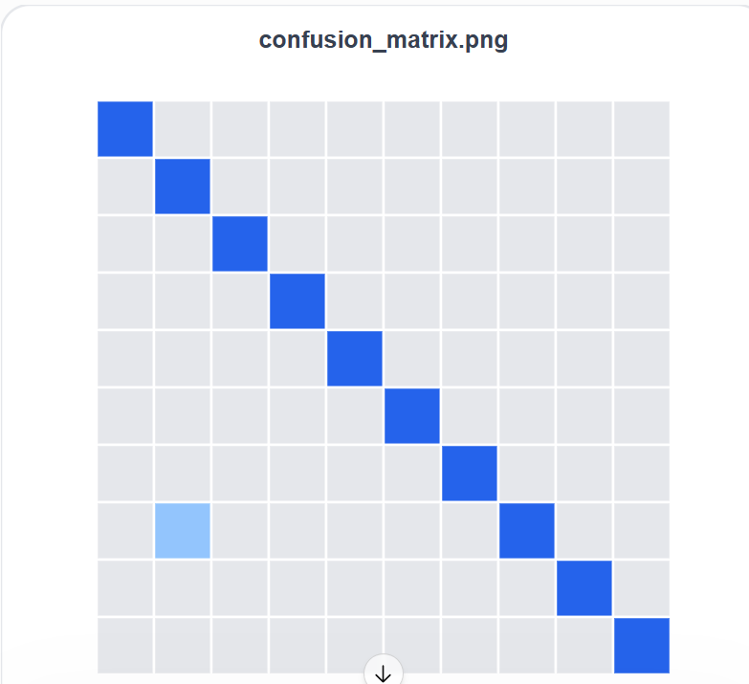
A perfect classifier would have only diagonal values.

4. Run Evaluation
After training finishes:
python -m src.evaluate
Expected terminal:
==================================================
Evaluation Completed
{'accuracy': 98.95,
'precision': 98.96,
'recall': 98.94,
'f1_score': 98.95}
==================================================

5. Final Project Structure
MNIST Handwritten Digit Recognition using CNN/

├── checkpoints/
│ └── best_model.pth
│
├── outputs/
│ ├── metrics.json
│ ├── confusion_matrix.png
│ └── classification_report.txt
│
└── src/
├── config.py
├── transforms.py
├── dataset.py
├── eda.py
├── model.py
├── engine.py
├── train.py
└── evaluate.py

Step 11: Error Analysis
Training tells you how accurate the model is.
Error analysis tells you why it makes mistakes.
This is one of the most important skills of a Deep Learning Engineer. Companies care more about your ability to analyze failures than simply reporting 99% accuracy.

What we will build
Create a new file:
src/error_analysis.py
It will generate:
outputs/
├── wrong_predictions.png
└── hardest_samples.png

Error Analysis Pipeline
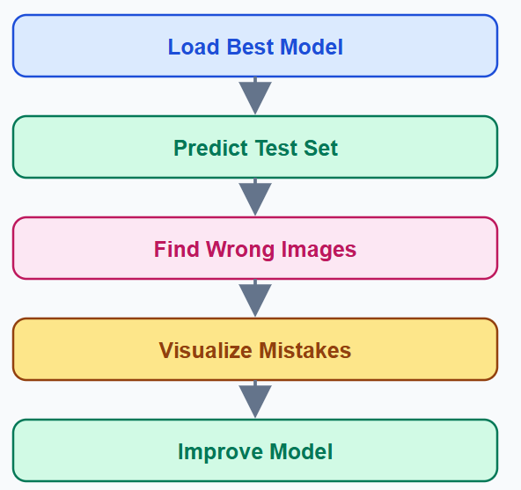

1. Why Error Analysis Matters
Imagine your CNN reports:
Accuracy=99%
That sounds excellent.
But suppose every 9 becomes 4.
A doctor or banker would care about which errors happen, not only the overall score.
Example mistakes:
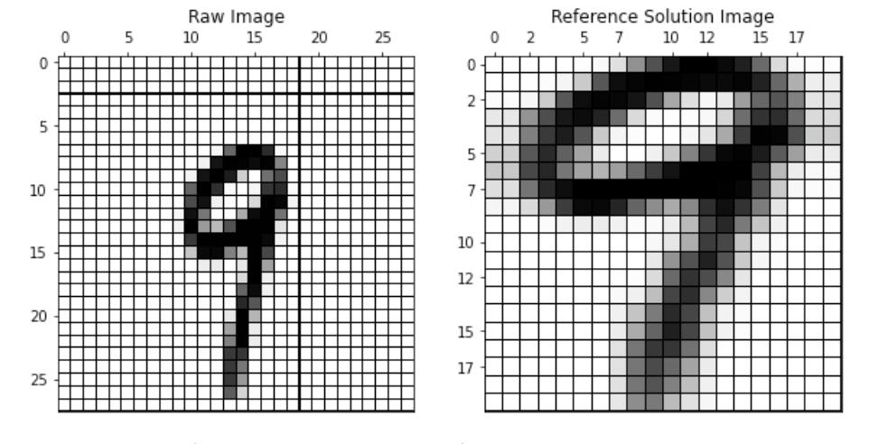
True: 9
Predicted: 4

True: 5
Predicted: 3
These reveal the model's weaknesses.

2. Complete error_analysis.py
import matplotlib.pyplot as plt
import torch

from .config import DEVICE, CHECKPOINT_DIR, OUTPUT_DIR
from .dataset import get_dataloaders
from .model import DigitCNN

def visualize_errors():

_, _, test_loader = get_dataloaders()

model = DigitCNN().to(DEVICE)

model.load_state_dict(
torch.load(
CHECKPOINT_DIR / "best_model.pth",
map_location=DEVICE
)
)

model.eval()

wrong_images = []
wrong_true = []
wrong_pred = []

with torch.no_grad():

for images, labels in test_loader:

images = images.to(DEVICE)

outputs = model(images)

_, predicted = torch.max(outputs, 1)

for i in range(len(labels)):

if predicted[i].cpu() != labels[i]:

wrong_images.append(images[i].cpu())

wrong_true.append(labels[i].item())

wrong_pred.append(predicted[i].cpu().item())

if len(wrong_images) == 16:
break

if len(wrong_images) == 16:
break

fig, axes = plt.subplots(4, 4, figsize=(8, 8))

for i, ax in enumerate(axes.flat):

ax.imshow(wrong_images[i].squeeze(), cmap="gray")

ax.set_title(
f"T:{wrong_true[i]} P:{wrong_pred[i]}",
fontsize=9
)

ax.axis("off")

plt.tight_layout()
plt.savefig(
OUTPUT_DIR / "wrong_predictions.png",
dpi=300
)

plt.show()

if __name__ == "__main__":
visualize_errors()

3. What this code does

Step A — Load model
model.load_state_dict(...)
Loads the learned CNN.

Step B — Predict
outputs = model(images)
Produces 10 scores.

Step C — Detect mistakes
if predicted[i] != labels[i]:
This is the most important line.
It asks:
"Did the CNN make a mistake?"
If yes:
- Save image
- Save true label
- Save predicted label

Step D — Visualize
Expected output:
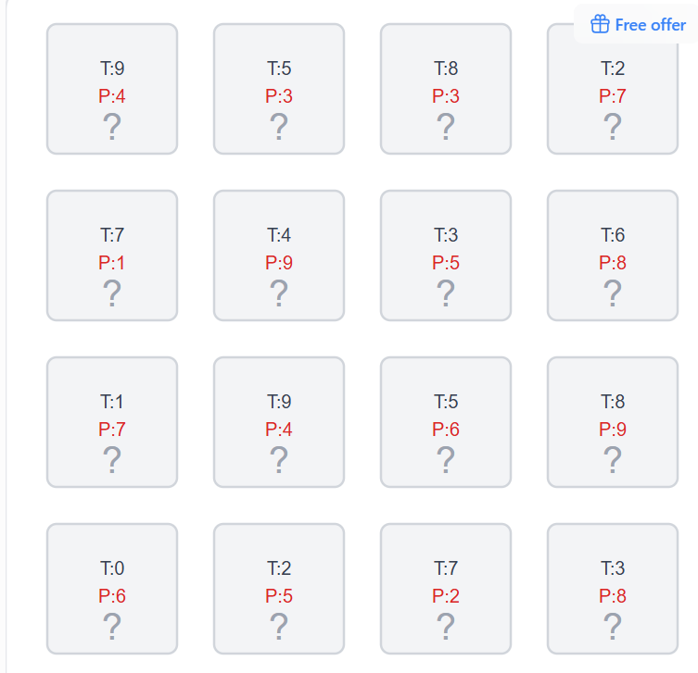
Each title means:
- T = True label
- P = Predicted label
Example:
T:9 P:4
The CNN thought the digit 9 looked like a 4.

4. How Engineers Analyze Errors
Instead of saying:
Accuracy = 99%
We write observations like:
Observation | Improvement
9 confused with 4 | More training data
5 confused with 3 | Data augmentation
Thin digits fail | Increase robustness
Tilted digits fail | Rotation augmentation
This becomes your Error Analysis section in GitHub.

5. Run
python -m src.error_analysis
Generated file:
outputs/
└── wrong_predictions.png

Step 11 Deliverables
- Load trained model
- Detect incorrect predictions
- Save wrong images
- Visual error inspection
- Professional error analysis workflow

Step 12: Inference System
Congratulations—your CNN can now learn and evaluate. The next step is making it useful: predicting a single new image.
Goal: Build inference.py that loads best_model.pth and predicts one handwritten digit with a confidence score.
This is the first deployable AI feature.

What is inference?
During training:
54,000 images → CNN → Learning
During inference:
1 new image → CNN → Predicted digit
The model does not learn anymore. It only uses the learned weights.
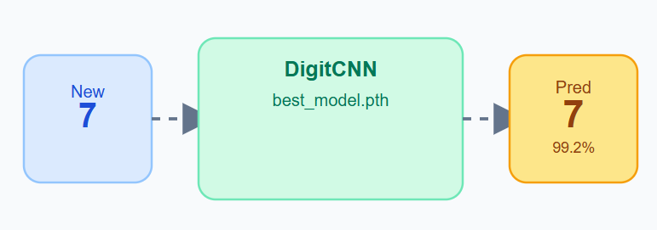

1. Create the file
src/
├── inference.py ← NEW

2. Complete inference.py
from pathlib import Path

import torch
from PIL import Image
from torchvision import transforms

from .config import DEVICE, CHECKPOINT_DIR
from .model import DigitCNN

transform = transforms.Compose([
transforms.Grayscale(),
transforms.Resize((28, 28)),
transforms.ToTensor(),
transforms.Normalize((0.1307,), (0.3081,))
])

def predict(image_path):

model = DigitCNN().to(DEVICE)

model.load_state_dict(
torch.load(
CHECKPOINT_DIR / "best_model.pth",
map_location=DEVICE
)
)

model.eval()

image = Image.open(image_path)

image = transform(image)

image = image.unsqueeze(0).to(DEVICE)

with torch.no_grad():

outputs = model(image)

probabilities = torch.softmax(outputs, dim=1)

confidence, prediction = torch.max(probabilities, 1)

return prediction.item(), confidence.item()

if __name__ == "__main__":

image = "sample.png"

digit, confidence = predict(image)

print("=" * 40)
print(f"Predicted Digit : {digit}")
print(f"Confidence : {confidence:.2%}")
print("=" * 40)

3. Why model.eval()?
Training uses:
model.train()
Inference uses:
model.eval()
Difference:
Training | Inference
Dropout ON | Dropout OFF
Gradients | No gradients
Learning | Prediction only
The weights stay exactly the same.

4. Why unsqueeze(0)?
Before:
(1,28,28)(1,28,28)(1,28,28)
The CNN expects a batch dimension.
After:
(1,1,28,28)(1,1,28,28)(1,1,28,28)
Meaning:
Dimension | Value
Batch | 1
Channel | 1
Height | 28
Width | 28
Even one image must be treated as a batch.

5. Softmax → Confidence
The CNN outputs raw scores:
[-2.1, 0.5, 8.2, 1.7, ...]
Softmax converts them into probabilities:

Result:
Digit = 2
Confidence = 98%

6. Test Image
Place a handwritten image here:
MNIST Handwritten Digit Recognition using CNN/

├── sample.png
├── checkpoints/
├── outputs/
└── src/
Example input:
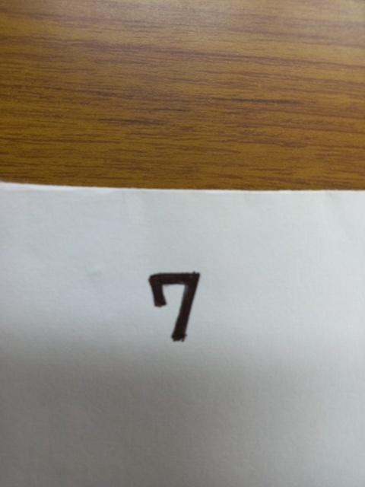
Run:
python -m src.inference
Expected output:
========================================
Predicted Digit : 7
Confidence : 99.18%
========================================

7. End-to-End Pipeline

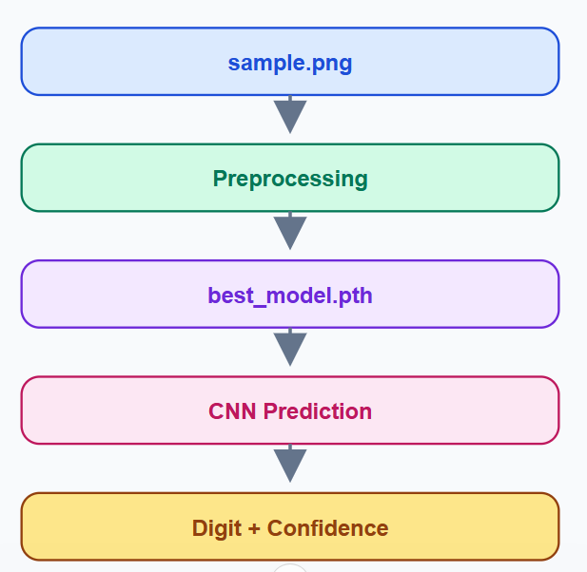
This is your first deployable computer vision application.

Project 01 Status
Step | Status
1–4 Setup | ✅
5 Data Pipeline | ✅
6 EDA | ✅
7 CNN Model | ✅
8 Training Engine | ✅
9 Train Script | ✅
10 Evaluation | ✅
11 Error Analysis | ✅
12 Inference | ✅
Your MNIST CNN project is now a complete end-to-end deep learning project with training, evaluation, error analysis, and inference.

Step 13: FastAPI Deployment (Production Level)
You have built a complete CNN. Now you'll turn it into a REST API so any application (Web, Mobile, React, Flutter, Streamlit) can send an image and receive a prediction.
What you'll build:
Client → FastAPI → CNN Model → Prediction + Confidence

1. Update the project structure
MNIST Handwritten Digit Recognition using CNN/

├── app/
│ └── api.py
│
├── checkpoints/
│ └── best_model.pth
│
├── src/
│ ├── model.py
│ ├── config.py
│ └── ...
app/ contains only deployment code. The training code stays inside src/.

2. Install FastAPI
pip install fastapi uvicorn python-multipart
python-multipart allows image uploads.

3. Create app/api.py
This is your production API.

from io import BytesIO

import torch
from fastapi import FastAPI, UploadFile, File
from PIL import Image
from torchvision import transforms

from src.model import DigitCNN
from src.config import DEVICE, CHECKPOINT_DIR

app = FastAPI(title="MNIST Digit Recognition API")

transform = transforms.Compose([
transforms.Grayscale(),
transforms.Resize((28, 28)),
transforms.ToTensor(),
transforms.Normalize((0.1307,), (0.3081,))
])

model = DigitCNN().to(DEVICE)
model.load_state_dict(
torch.load(
CHECKPOINT_DIR / "best_model.pth",
map_location=DEVICE
)
)
model.eval()

@app.get("/")
def home():
return {"message": "MNIST CNN API is running"}

@app.post("/predict")
async def predict(file: UploadFile = File(...)):
image_bytes = await file.read()

image = Image.open(BytesIO(image_bytes))

image = transform(image)

image = image.unsqueeze(0).to(DEVICE)

with torch.no_grad():
outputs = model(image)

probabilities = torch.softmax(outputs, dim=1)

confidence, prediction = torch.max(probabilities, 1)

return {
"predicted_digit": int(prediction.item()),
"confidence": round(float(confidence.item()), 4)
}

4. Why is the model loaded outside the endpoint?
Notice this part:
model = DigitCNN().to(DEVICE)

model.load_state_dict(...)

model.eval()
It is outside predict().
Inside predict() | Outside predict()
❌ Loads model every request | ✅ Loads once
Slow | Fast
High memory | Efficient
A senior deployment loads the model one time when the server starts.

5. Run the API
From the project root:
uvicorn app.api:app --reload
Expected output:
INFO: Uvicorn running on http://127.0.0.1:8000

6. Open Swagger UI
Visit:
http://127.0.0.1:8000/docs
You'll see an interactive interface where you can upload an image.
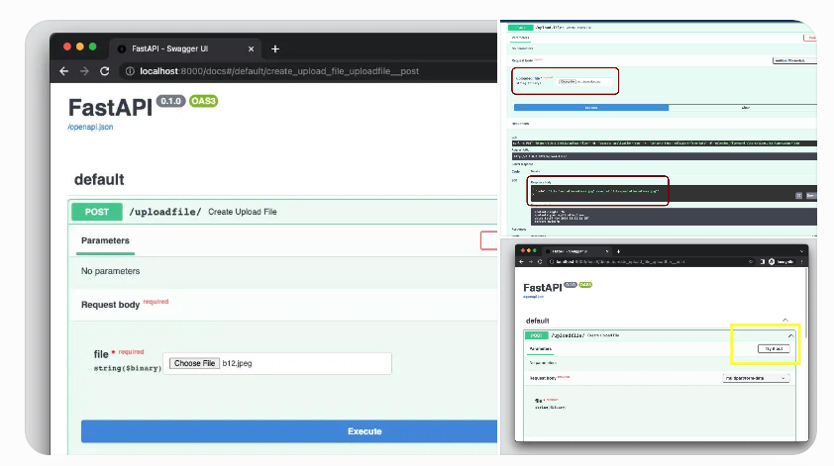

7. Test the /predict endpoint
Upload:
sample.png
The API returns:
{
"predicted_digit": 7,
"confidence": 0.9918
}

8. API Response Flow
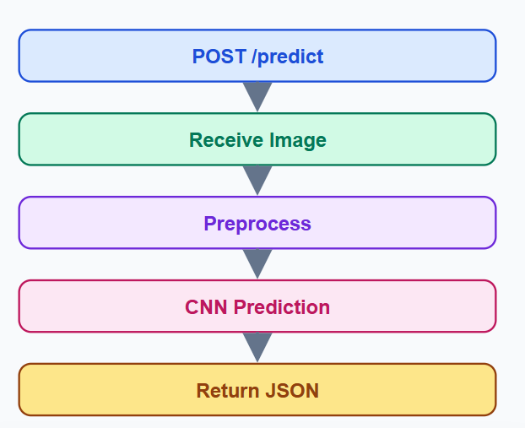

Final Project Architecture
MNIST Handwritten Digit Recognition using CNN/

├── app/
│ └── api.py ← Deployment
│
├── checkpoints/
│ └── best_model.pth
│
├── outputs/
│ ├── metrics.json
│ ├── confusion_matrix.png
│ └── wrong_predictions.png
│
├── src/
│ ├── config.py
│ ├── transforms.py
│ ├── dataset.py
│ ├── eda.py
│ ├── model.py
│ ├── engine.py
│ ├── train.py
│ ├── evaluate.py
│ ├── error_analysis.py
│ └── inference.py
│
├── requirements.txt
└── README.md

Step 14: Documentation (Professional README)
A senior deep learning project is not complete until it has professional documentation. This is what recruiters and GitHub visitors read first.

What we'll create
README.md
It should explain the entire project—not just how to run it.

README structure
Section | Purpose
Project Title | What the project is
Business Problem | Why it exists
Dataset | Source and statistics
Model Architecture | CNN design
Training | Hyperparameters
Results | Metrics
Project Structure | Folder organization
Installation | Setup
Usage | Train, evaluate, inference, API
Future Improvements | Next ideas

Complete README.md
MNIST Handwritten Digit Recognition using CNN
# MNIST Handwritten Digit Recognition using CNN

A production-style Deep Learning project built with **PyTorch** that recognizes handwritten digits (0–9) using a custom Convolutional Neural Network (CNN). The project includes training, evaluation, error analysis, inference, and FastAPI deployment.

## Business Problem

Banks, postal services, and document processing systems need to automatically recognize handwritten digits. This project demonstrates how a CNN can solve that problem with high accuracy.

## Dataset

- **Dataset:** MNIST
- **Training images:** 60,000
- **Test images:** 10,000
- **Image size:** 28×28 grayscale
- **Classes:** 10 digits (0–9)

## Model Architecture

- Convolution Layer 1
- ReLU
- Max Pooling
- Convolution Layer 2
- ReLU
- Max Pooling
- Fully Connected Layer
- Dropout
- Output Layer (10 classes)

## Training Configuration

| Parameter | Value |
| ------------- | ---------------: |
| Epochs | 10 |
| Batch Size | 64 |
| Learning Rate | 0.001 |
| Optimizer | Adam |
| Loss Function | CrossEntropyLoss |

## Results

The model produces:

- Accuracy
- Precision
- Recall
- F1 Score
- Confusion Matrix

All metrics are saved automatically inside the `outputs/` folder.

## Project Structure

```text
MNIST-CNN/
├── app/
├── checkpoints/
├── outputs/
├── src/
├── requirements.txt
└── README.md
```

## Installation

```bash
pip install -r requirements.txt
```

## Train

```bash
python -m src.train
```

## Evaluate

```bash
python -m src.evaluate
```

## Error Analysis

```bash
python -m src.error_analysis
```

## Inference

```bash
python -m src.inference
```

## FastAPI

```bash
uvicorn app.api:app --reload
```

Then open:

```text
http://127.0.0.1:8000/docs
```

## Future Improvements

- ResNet implementation
- Grad-CAM visualization
- Mixed Precision Training
- ONNX export
- Docker deployment

This is one of the biggest differences between a beginner and a senior deep learning project.
Your current code only saves:
best_model.pth
That is enough for inference, but not enough to continue training.
A senior project saves the entire training state.

What is a checkpoint?
A checkpoint is a snapshot of the whole training process.
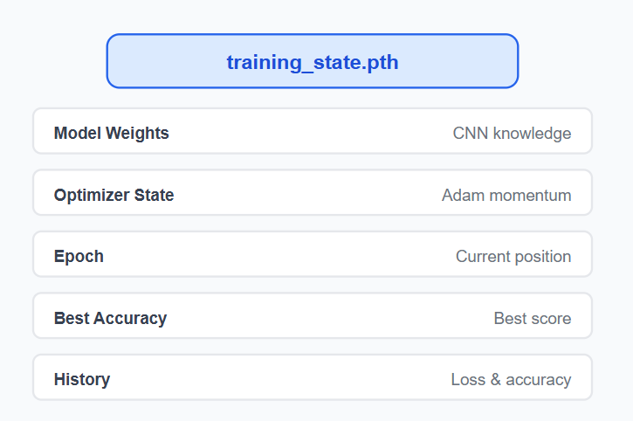
Instead of saving only weights, we save everything.

Why do we need it?
Imagine this happens:
Epoch | Validation Accuracy
1 | 95.12%
2 | 97.31%
3 | 98.42%
4 | 98.88%
5 | 99.01%
6 | 99.08%
7 | 99.12%
Suddenly your laptop shuts down.
Without a checkpoint:
❌ Start again from Epoch 1.
With a checkpoint:
✅ Resume from Epoch 8.

Three different .pth files
File | Purpose
best_model.pth | Best model for inference
last_checkpoint.pth | Resume training
training_state.pth | Complete experiment snapshot
best_model.pth and last_checkpoint.pth are not the same.

Step 1 — Create src/checkpoint.py
src/
├── checkpoint.py
This file will manage saving and loading.
import torch

def save_checkpoint(
model,
optimizer,
epoch,
best_acc,
history,
filepath
):

checkpoint = {
"epoch": epoch,
"model_state": model.state_dict(),
"optimizer_state": optimizer.state_dict(),
"best_accuracy": best_acc,
"history": history
}

torch.save(checkpoint, filepath)

Think of it like a backpack:
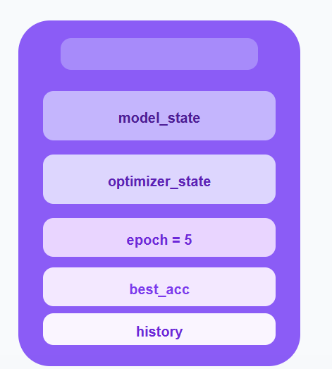

Step 3 — Load Function
Src/Checkpoint.py
import torch

def save_checkpoint(
model,
optimizer,
epoch,
best_acc,
history,
filepath
):
checkpoint = {
"epoch": epoch,
"model_state": model.state_dict(),
"optimizer_state": optimizer.state_dict(),
"best_accuracy": best_acc,
"history": history
}

torch.save(checkpoint, filepath)

def load_checkpoint(filepath, model, optimizer):

checkpoint = torch.load(filepath)

model.load_state_dict(
checkpoint["model_state"]
)

optimizer.load_state_dict(
checkpoint["optimizer_state"]
)

return (
checkpoint["epoch"],
checkpoint["best_accuracy"],
checkpoint["history"]
)

This restores exactly where training stopped.

Step 4 — Update train.py
Import it:
from .checkpoint import save_checkpoint
Inside the epoch loop:
history = {
"train_loss": [],
"val_loss": [],
"train_acc": [],
"val_acc": []
}
After every epoch:
history["train_loss"].append(train_loss)
history["val_loss"].append(val_loss)

history["train_acc"].append(train_acc)
history["val_acc"].append(val_acc)
Then save:
save_checkpoint(
model=model,
optimizer=optimizer,
epoch=epoch + 1,
best_acc=best_accuracy,
history=history,
filepath=CHECKPOINT_DIR / "last_checkpoint.pth"
)
Now every epoch updates the checkpoint.

Step 5 — Resume Training
Suppose training stopped at Epoch 6.
Later:
start_epoch, best_acc, history = load_checkpoint(
CHECKPOINT_DIR / "last_checkpoint.pth",
model,
optimizer
)
Then continue:
for epoch in range(start_epoch, EPOCHS):
If start_epoch = 6, the next epoch becomes 7.

Memory Flow

What you learned in Step 14
Concept | Purpose
model.state_dict() | Save learned weights
optimizer.state_dict() | Save Adam's internal state
epoch | Resume from the correct epoch
history | Keep previous metrics
torch.save() | Serialize the entire experiment
torch.load() | Restore training exactly

Step 15: Learning Rate Scheduler
Up to now, your learning rate has been fixed:
LR=0.001
A senior project rarely keeps the same learning rate for the entire training. Instead, it changes automatically as training progresses.
Goal: Make the optimizer learn fast at the beginning and more carefully near the end.

Why do we change the learning rate?
Imagine climbing a mountain.
- At the bottom → Take big steps
- Near the top → Take small careful steps
Training behaves the same way.
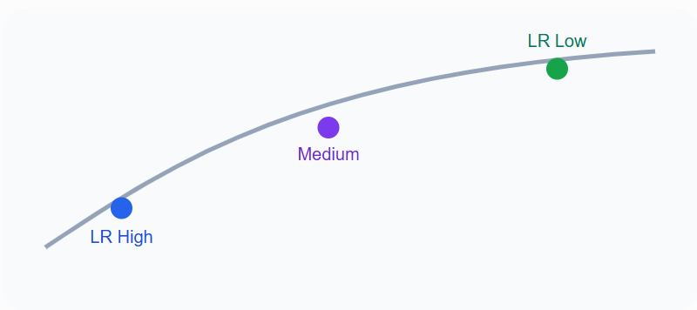
Large learning rates help find the region. Small learning rates help find the optimum.

What is a scheduler?
The scheduler does not replace Adam.
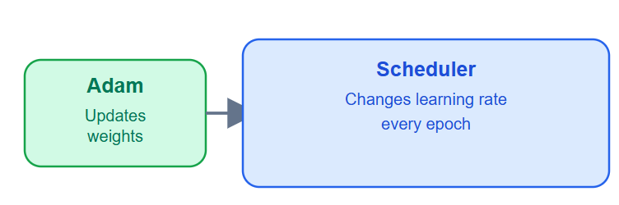
Think of it like this:
- Optimizer → Changes weights
- Scheduler → Changes the optimizer's learning rate

Types of schedulers
Scheduler | Used for
StepLR | Reduce every N epochs
MultiStepLR | Reduce at specific epochs
CosineAnnealingLR | Modern CNNs
ReduceLROnPlateau | Best for validation monitoring
For MNIST we'll use StepLR because it's easy to understand.

Learning rate over epochs
Suppose:
- Initial LR = 0.001
- Step size = 3
- Gamma = 0.1
StepLR learning rate schedule
Learning rate drops by 10× every 3 epochs.
00.000250.00050.000750.00112345678910
Instead of staying constant, it becomes smaller.

Step 1 — Update config.py
Add these hyperparameters:
# Learning Rate Scheduler
STEP_SIZE = 3
GAMMA = 0.1
Now your experiment is fully configurable.

Step 2 — Create the scheduler
Inside train.py:
from torch.optim.lr_scheduler import StepLR
After creating Adam:
optimizer = torch.optim.Adam(
model.parameters(),
lr=LEARNING_RATE
)

scheduler = StepLR(
optimizer,
step_size=STEP_SIZE,
gamma=GAMMA
)
Notice something important:
The scheduler receives the optimizer, not the model.

Step 3 — Update every epoch
At the end of the epoch:
scheduler.step()
Your loop becomes:
for epoch in range(EPOCHS):

train_loss, train_acc = ...

val_loss, val_acc = ...

scheduler.step()
This changes the optimizer's learning rate for the next epoch.

Step 4 — Print the current LR
Add this:
current_lr = optimizer.param_groups[0]["lr"]

print(f"Learning Rate: {current_lr:.6f}")
Expected output:
Epoch 1
LR: 0.001000

Epoch 2
LR: 0.001000

Epoch 3
LR: 0.001000

Epoch 4
LR: 0.000100

Epoch 7
LR: 0.000010
Now you can actually watch it change.

What happens internally?
Before scheduler.step():
optimizer.lr = 0.001
After Epoch 3:
scheduler.step()
Becomes:
optimizer.lr = 0.0001
Nothing else changes.
- Model → Same
- Weights → Same
- Optimizer → Same object
- Learning rate → Updated
The scheduler is always the last step of an epoch.

Step 15 Summary
Component | Responsibility
Adam | Updates weights
Scheduler | Updates learning rate
StepLR | Reduces LR every few epochs
scheduler.step() | Executes the LR update
optimizer.param_groups[0]["lr"] | Reads the current LR

Step 16: Early Stopping
Up to now, your model always trains for 10 epochs. But what if it reaches its best performance at epoch 6?
A senior deep learning project stops automatically when the model is no longer improving.
Goal: Prevent overfitting and save training time.

Why Early Stopping?
Imagine your validation accuracy looks like this:
Validation accuracy across epochs
Training should stop after the best model stops improving.
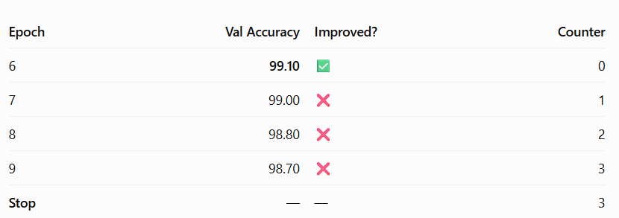The best model is at Epoch 6.
Continuing to epoch 10 only makes the model worse.
Early stopping says:
"Stop training if validation performance doesn't improve for several epochs."

The new concept: Patience
Patience means:
How many bad epochs am I willing to tolerate?
Example:
Epoch | Val Accuracy | Improved? | Counter
6 | 99.10 | ✅ | 0
7 | 99.00 | ❌ | 1
8 | 98.80 | ❌ | 2
9 | 98.70 | ❌ | 3
Stop | — | — | 3
If PATIENCE = 3, training stops after Epoch 9.

Step 1 — Update config.py
Add:
# Early Stopping
PATIENCE = 3
Now everything stays configurable.

Step 2 — Initialize variables
Inside train.py, before the epoch loop:
best_accuracy = 0

patience_counter = 0
We now track two things:
- Best validation accuracy
- Number of consecutive bad epochs

Step 3 — Update the logic
Replace your best-model block with this:
if val_acc > best_accuracy:

best_accuracy = val_acc

patience_counter = 0

torch.save(
model.state_dict(),
CHECKPOINT_DIR / "best_model.pth"
)

print("Best model saved!")

else:

patience_counter += 1

print(
f"No improvement ({patience_counter}/{PATIENCE})"
)
Notice something important:
Every improvement resets patience back to 0.

Step 4 — Stop automatically
Immediately after that block:
if patience_counter >= PATIENCE:

print("=" * 50)
print("Early Stopping Triggered")
print("=" * 50)

break
The break exits the epoch loop.

Complete Training Flow
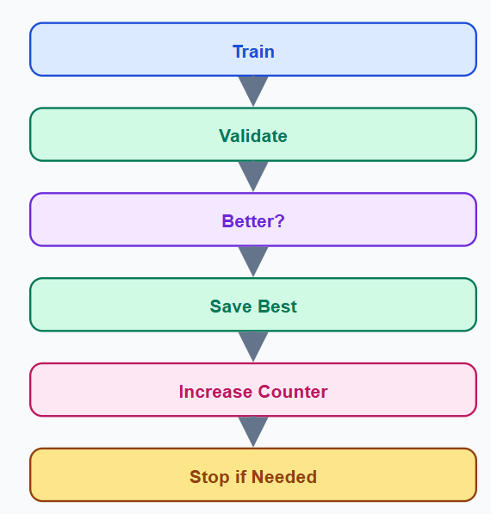
This is the exact logic used in many production training pipelines.

Expected Terminal Output
Epoch 6
Val Accuracy: 99.10%
Best model saved!

Epoch 7
Val Accuracy: 99.00%
No improvement (1/3)

Epoch 8
Val Accuracy: 98.80%
No improvement (2/3)

Epoch 9
Val Accuracy: 98.70%
No improvement (3/3)

==================================================
Early Stopping Triggered
==================================================
Training ends automatically.

Why is this better?
Without Early Stopping | With Early Stopping
Trains unnecessarily | Stops automatically
Can overfit | Better generalization
Wastes GPU time | Saves computation
Fixed epochs | Adaptive training

Step 16 Summary
You added one of the most important production features:
- PATIENCE
- patience_counter
- Reset on improvement
- Automatic break
- Best model preserved

Step 17: Hyperparameter Configuration
This step is about experiment management. A senior engineer should be able to change an experiment by editing one file only—config.py.
Goal: Centralize every tunable parameter into one configuration system.

Why is this important?
Right now your values are scattered:
lr = 0.001
batch_size = 64
epochs = 10
dropout = 0.5
Instead, every experiment should be controlled from one place.
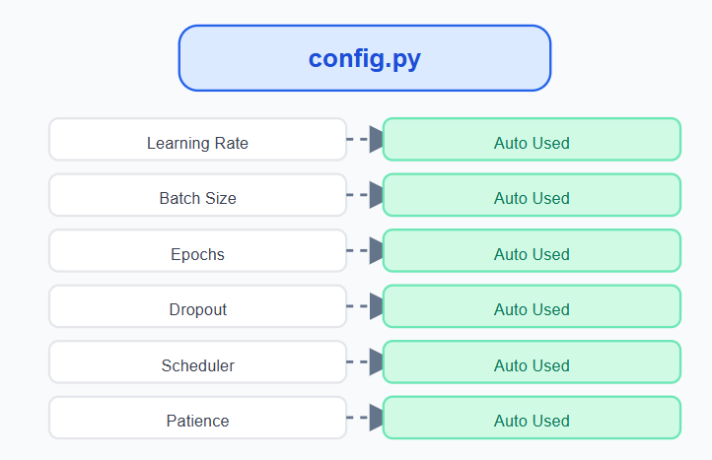
Every module imports from config.py.

Step 1 — Upgrade config.py
Replace the hyperparameter section with this professional version:
from pathlib import Path
import torch

# ==========================
# Project Paths
# ==========================
PROJECT_ROOT = Path(__file__).resolve().parent.parent

DATA_DIR = PROJECT_ROOT / "data"
CHECKPOINT_DIR = PROJECT_ROOT / "checkpoints"
OUTPUT_DIR = PROJECT_ROOT / "outputs"

# Create folders automatically
CHECKPOINT_DIR.mkdir(parents=True, exist_ok=True)
OUTPUT_DIR.mkdir(parents=True, exist_ok=True)

# ==========================
# Dataset
# ==========================
IMAGE_SIZE = 28
NUM_CLASSES = 10
CHANNELS = 1

# ==========================

# ==========================
# Training
# ==========================
BATCH_SIZE = 64
VALID_SPLIT = 0.10
SEED = 42
# ==========================
# Training Hyperparameters
# ==========================
EPOCHS = 20
LEARNING_RATE = 0.001
# Learning Rate Scheduler
STEP_SIZE = 3
GAMMA = 0.1

WEIGHT_DECAY = 1e-4
# Model
DROPOUT = 0.50
# ==========================
# Early Stopping
PATIENCE = 3
# ==========================
# Device
# ==========================
DEVICE = "cuda" if torch.cuda.is_available() else "cpu"
Now your project has one single source of truth.

Step 2 — Use Dropout from Config
Currently, your model probably contains:
self.dropout = nn.Dropout(0.5)
Replace it with:
from .config import DROPOUT
Then:
self.dropout = nn.Dropout(DROPOUT)
Now changing the dropout requires editing only config.py.

Step 3 — Weight Decay
Import it inside train.py:
from .config import WEIGHT_DECAY
Replace Adam with:
optimizer = torch.optim.Adam(
model.parameters(),
lr=LEARNING_RATE,
weight_decay=WEIGHT_DECAY
)

What is Weight Decay?
Weight decay is L2 regularization.
It discourages extremely large weights.
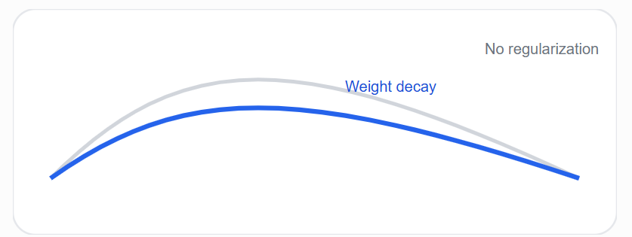
Benefits:
- Better generalization
- Less overfitting
- More stable CNN

Step 4 — Reproducibility
Create a new file:
src/utils.py
import random
import numpy as np
import torch

def set_seed(seed):
random.seed(seed)
np.random.seed(seed)
torch.manual_seed(seed)
torch.cuda.manual_seed_all(seed)

torch.backends.cudnn.deterministic = True
torch.backends.cudnn.benchmark = False
Now every experiment becomes reproducible.

Why reproducibility matters
Without seed:
Run | Accuracy
1 | 98.61%
2 | 99.08%
3 | 98.42%
With SEED = 42:
Run | Accuracy
1 | 98.91%
2 | 98.91%
3 | 98.91%
This is essential for research and production.

Step 17 Summary
You transformed your project into a configurable experiment system.
Feature | Status
Centralized Config | ✅
Dropout Configurable | ✅
Weight Decay | ✅
Seed Control | ✅
Reproducibility | ✅
This is the same design pattern you'll reuse in ResNet, EfficientNet, YOLO, U-Net, and Vision Transformers.

Step 18 — Experiment Logging (CSV & JSON)

Goal
A senior project should record every epoch so you can compare experiments later. Instead of only printing results in the terminal, we'll save them to files.

New files created
outputs/
├── training_log.csv ← Every epoch
├── metrics.json ← Final results
└── loss_curve.png ← Step 19

What we'll do
We will modify 2 files only.
File | Action
src/logger.py | Create new
src/train.py | Add logging

1. Create src/logger.py
Create a new file:
src/
├── logger.py ← NEW
Paste this complete code:
import csv
from pathlib import Path

from .config import OUTPUT_DIR

def create_log_file():

OUTPUT_DIR.mkdir(exist_ok=True)

log_file = OUTPUT_DIR / "training_log.csv"

with open(log_file, "w", newline="") as f:

writer = csv.writer(f)

writer.writerow([
"epoch",
"train_loss",
"train_accuracy",
"val_loss",
"val_accuracy",
"learning_rate"
])

return log_file

def log_epoch(
log_file,
epoch,
train_loss,
train_acc,
val_loss,
val_acc,
lr
):

with open(log_file, "a", newline="") as f:

writer = csv.writer(f)

writer.writerow([
epoch,
train_loss,
train_acc,
val_loss,
val_acc,
lr
])

2. Update src/train.py

Step A — Add import
At the top, with the other imports, add:
from .logger import create_log_file, log_epoch

Step B — Create the CSV
Inside main(), after set_seed(SEED) and before loading the data:
log_file = create_log_file()

train_loader, val_loader, test_loader = get_dataloaders()
It should look like:
def main():

set_seed(SEED)

log_file = create_log_file()

train_loader, val_loader, test_loader = get_dataloaders()

Step C — Log every epoch
Inside the epoch loop, after you calculate current_lr and before the best-model section, add:
log_epoch(
log_file,
epoch + 1,
train_loss,
train_acc,
val_loss,
val_acc,
current_lr
)

Exact position
current_lr = optimizer.param_groups[0]["lr"]

log_epoch(
log_file,
epoch + 1,
train_loss,
train_acc,
val_loss,
val_acc,
current_lr
)

if val_acc > best_accuracy:
...

3. Run the project
python -m src.train

4. Verify the output
Open:
outputs/training_log.csv
It should look like this:
epoch | train_loss | train_accuracy | val_loss | val_accuracy | learning_rate
1 | 0.2145 | 94.82 | 0.0812 | 97.56 | 0.001
2 | 0.0914 | 97.88 | 0.0511 | 98.31 | 0.001
3 | 0.0620 | 98.62 | 0.0407 | 98.91 | 0.001
This CSV becomes the source of truth for plotting learning curves in the next step.

What you learned
Concept | Purpose
create_log_file() | Creates the experiment CSV
log_epoch() | Saves one epoch
CSV logging | Compare multiple experiments
OUTPUT_DIR | Stores reproducible results
Purpose: Automatically save the results of every training epoch instead of only printing them in the terminal.

What Step 18 includes
- CSV logging: Save each epoch's metrics (training_log.csv)
- JSON metrics: Save final experiment results (metrics.json)
- Record:
  - Epoch number
  - Training loss
  - Training accuracy
  - Validation loss
  - Validation accuracy
  - Learning rate

Output files
outputs/
├── training_log.csv
└── metrics.json

Step 19: Learning Curves Visualization
This step turns your training_log.csv into professional graphs.
Goal: Automatically generate:
outputs/
├── loss_curve.png
└── accuracy_curve.png
These graphs are included in almost every professional deep learning GitHub project.

What you'll modify
File | Action
src/visualize.py | Create new
src/train.py | Call the visualization function

1. Create src/visualize.py
Create this new file:
src/
├── visualize.py ← NEW
Paste this complete code:
import pandas as pd
import matplotlib.pyplot as plt

from .config import OUTPUT_DIR

def plot_learning_curves():

log_file = OUTPUT_DIR / "training_log.csv"

df = pd.read_csv(log_file)

# Loss Curve
plt.figure(figsize=(8,5))
plt.plot(df["epoch"], df["train_loss"], label="Train Loss")
plt.plot(df["epoch"], df["val_loss"], label="Validation Loss")
plt.title("Loss Curve")
plt.xlabel("Epoch")
plt.ylabel("Loss")
plt.legend()
plt.grid(True)
plt.savefig(OUTPUT_DIR / "loss_curve.png", dpi=300)
plt.close()

# Accuracy Curve
plt.figure(figsize=(8,5))
plt.plot(df["epoch"], df["train_accuracy"], label="Train Accuracy")
plt.plot(df["epoch"], df["val_accuracy"], label="Validation Accuracy")
plt.title("Accuracy Curve")
plt.xlabel("Epoch")
plt.ylabel("Accuracy (%)")
plt.legend()
plt.grid(True)
plt.savefig(OUTPUT_DIR / "accuracy_curve.png", dpi=300)
plt.close()

print("Learning curves saved successfully!")

2. Update src/train.py

Step A — Add the import
At the top with the other imports:
from .visualize import plot_learning_curves

Step B — Call it at the end
Find the last part of main():
print("=" * 55)
print("TRAINING FINISHED")
print(f"Best Validation Accuracy: {best_accuracy:.2f}%")
print("=" * 55)
Immediately below it, add:
plot_learning_curves()
So the ending becomes:
print("=" * 55)
print("TRAINING FINISHED")
print(f"Best Validation Accuracy: {best_accuracy:.2f}%")
print("=" * 55)

plot_learning_curves()

3. Run the project
python -m src.train
After training finishes, you'll get:
outputs/
├── training_log.csv
├── loss_curve.png
└── accuracy_curve.png

Expected graphs

Loss Curve
The validation loss should generally decrease and then stabilize.
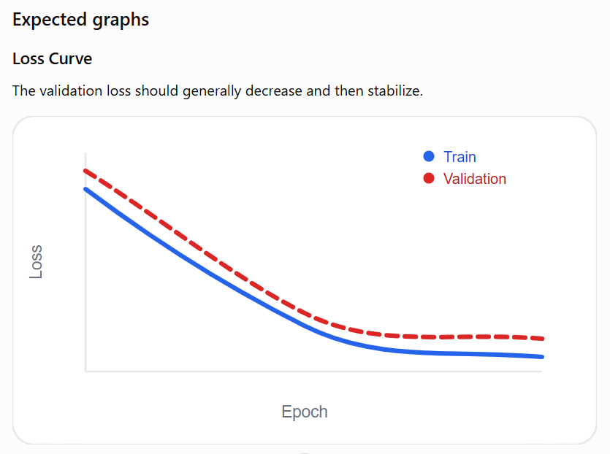

Accuracy Curve
The accuracy should increase with epochs.

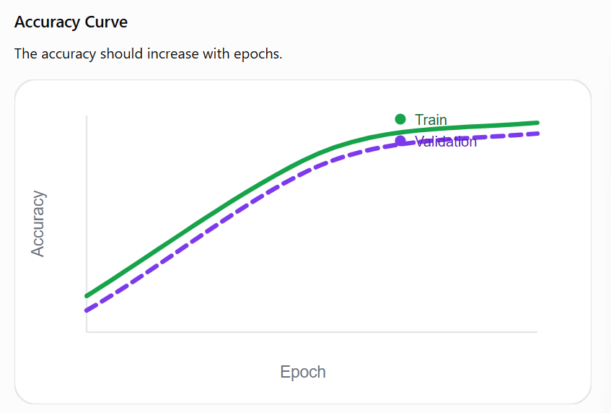

Step 20 — Grad-CAM & Model Explainability

Objective
Build a system that explains the CNN's prediction by showing which pixels influenced the decision.
Example
Input image
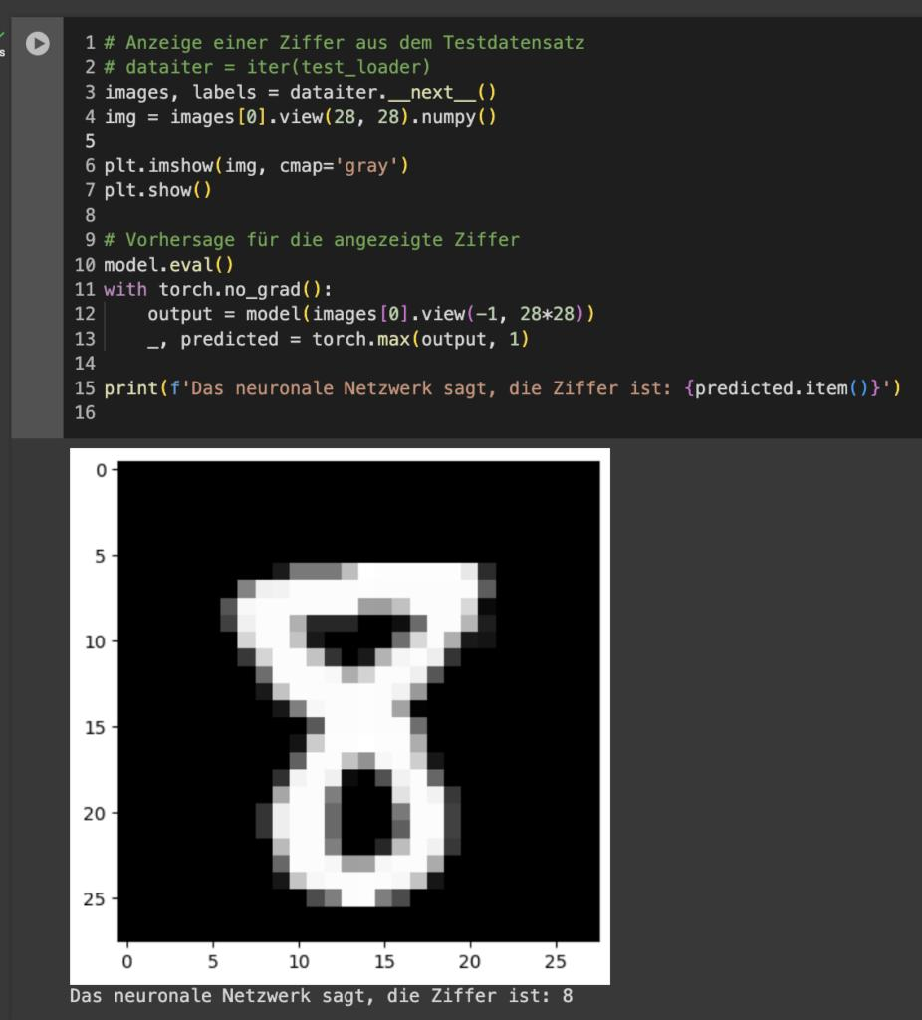
Grad-CAM output
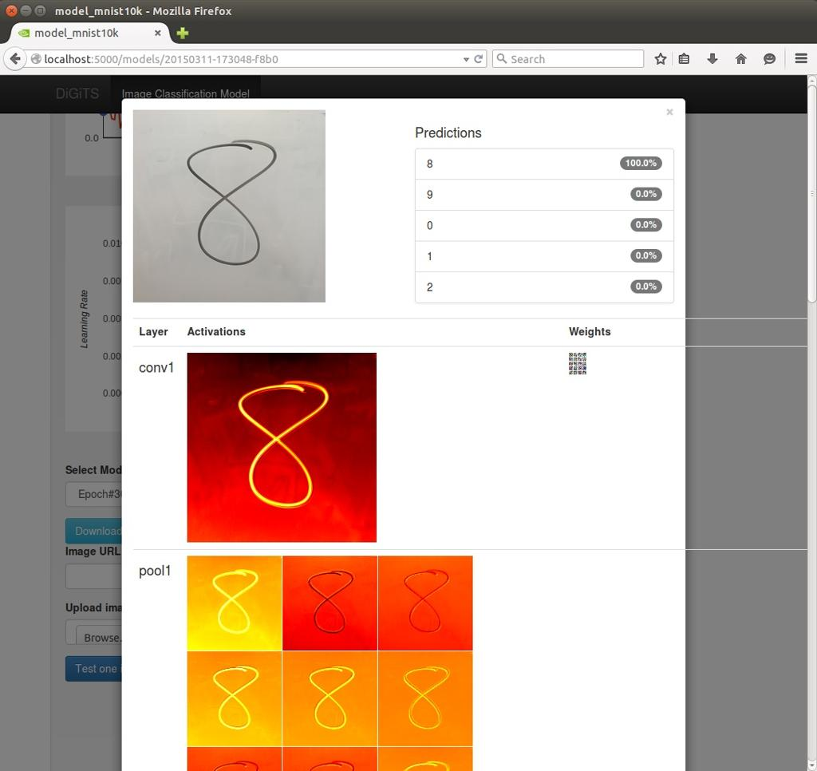
The heatmap tells us where the CNN looked.

Project structure
You will modify only one file and create one new file.
src/
├── model.py (small check only)
├── gradcam.py ← NEW

Step 1 — Check model.py
File: src/model.py
You do not need to change the architecture.
Just verify that your last convolution layer has a name.
It should look like this:
self.conv1 = nn.Conv2d(1, 16, kernel_size=3, padding=1)

self.conv2 = nn.Conv2d(16, 32, kernel_size=3, padding=1)
Important: The layer name must be conv2 because Grad-CAM will access model.conv2.
Nothing else changes.

Step 2 — Create gradcam.py
Create a new file
src/
└── gradcam.py
Paste this complete code.
from PIL import Image
import matplotlib.pyplot as plt
import numpy as np
import cv2

import torch
from torchvision import transforms

from .model import DigitCNN
from .config import DEVICE, CHECKPOINT_DIR

# -----------------------------
# Image Transform
# -----------------------------
transform = transforms.Compose([
transforms.Grayscale(),
transforms.Resize((28, 28)),
transforms.ToTensor(),
transforms.Normalize((0.1307,), (0.3081,))
])

# -----------------------------
# Global Variables
# -----------------------------
gradients = None
activations = None

# -----------------------------
# Hooks
# -----------------------------
def forward_hook(module, input, output):
global activations
activations = output

def backward_hook(module, grad_input, grad_output):
global gradients
gradients = grad_output[0]

# -----------------------------
# Load Model
# -----------------------------
model = DigitCNN().to(DEVICE)

model.load_state_dict(
torch.load(
CHECKPOINT_DIR / "best_model.pth",
map_location=DEVICE
)
)

model.eval()

# Register Hooks
model.conv2.register_forward_hook(forward_hook)
model.conv2.register_full_backward_hook(backward_hook)

# -----------------------------
# Generate Grad-CAM
# -----------------------------
def generate_gradcam(image_path):

image = Image.open(image_path)

img_tensor = transform(image).unsqueeze(0).to(DEVICE)

output = model(img_tensor)

prediction = output.argmax(dim=1)

model.zero_grad()

output[0, prediction].backward()

weights = gradients.mean(dim=[0, 2, 3])

feature_maps = activations.squeeze()

for i in range(len(weights)):
feature_maps[i] *= weights[i]

heatmap = feature_maps.mean(dim=0).cpu().detach().numpy()

heatmap = np.maximum(heatmap, 0)

heatmap = heatmap / heatmap.max()

heatmap = cv2.resize(heatmap, (28, 28))

plt.figure(figsize=(6, 6))

plt.imshow(image, cmap="gray")

plt.imshow(heatmap, cmap="jet", alpha=0.5)

plt.title(f"Predicted Digit : {prediction.item()}")

plt.axis("off")

plt.show()

if __name__ == "__main__":

generate_gradcam("sample.png")

Step 3 — Install OpenCV
Run once:
pip install opencv-python

Step 4 — Add the test image
Place one image in your project root.
MNIST Handwritten Digit Recognition using CNN/

├── sample.png
├── src/
├── outputs/
└── checkpoints/
Example:

Step 5 — Run
From the project root:
python -m src.gradcam

What happens internally?

1. Forward Pass
output = model(img_tensor)
Flow:
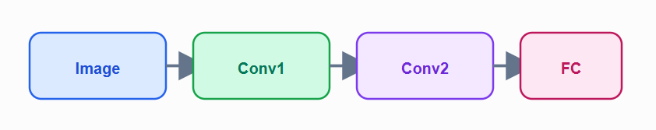
The forward hook stores the output of conv2.
activations = output
These are called feature maps.

2. Backward Pass
output[0, prediction].backward()
This computes gradients only for the predicted digit.
The backward hook stores them.
gradients = grad_output[0]
Now we have two things:
Variable | Meaning
activations | What the CNN saw
gradients | What was important

3. Importance Weights
weights = gradients.mean(dim=[0,2,3])
Suppose Conv2 produced 32 feature maps.
Grad-CAM computes one importance value for each.
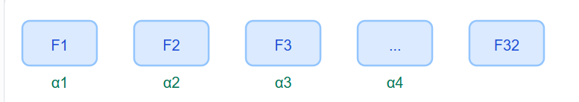
Each feature map gets a weight.

4. Build the Heatmap
feature_maps[i] *= weights[i]
Every feature map is multiplied by its importance.
Then:
heatmap = feature_maps.mean(dim=0)
Result:
Feature maps
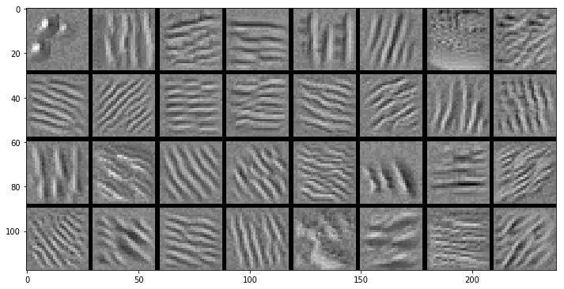
Final heatmap
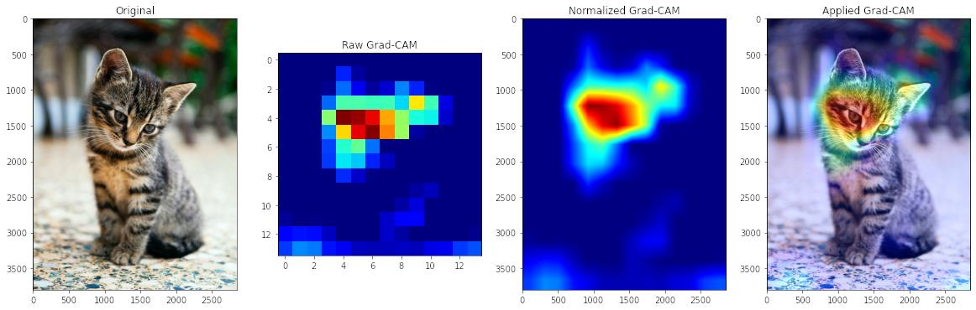

5. Overlay
plt.imshow(image, cmap="gray")
plt.imshow(heatmap, cmap="jet", alpha=0.5)
The original image stays visible.
The heatmap is drawn on top with 50% transparency.

Final output
When you run:
python -m src.gradcam
You'll see something similar to:
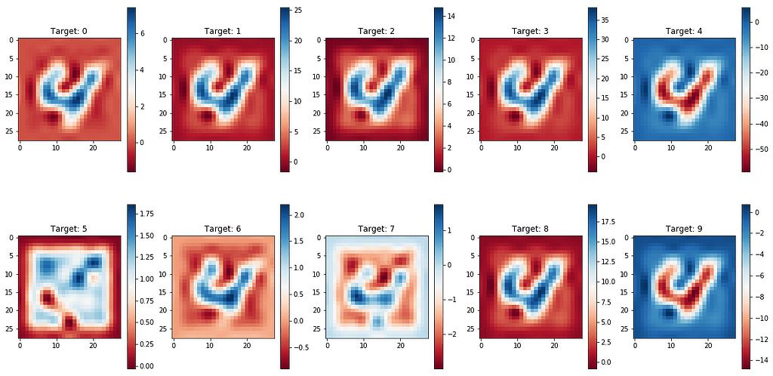
Interpretation
Color | Meaning
🔴 Red | Strong influence
🟡 Yellow | Medium influence
🔵 Blue | Little influence

Deliverables for Step 20
- Create src/gradcam.py
- Use hooks to capture activations and gradients
- Generate Grad-CAM heatmap
- Overlay the heatmap on the original image
- Explain the CNN's decision visually
This completes Step 20 of your senior deep learning project

Step 21: FastAPI Deployment
Now we'll deploy your trained CNN as a REST API. This is the same pattern used when connecting AI models to web apps, mobile apps, or frontend frameworks.
Goal: A user uploads an image and receives:
{
"predicted_digit": 7,
"confidence": 0.9918
}

What you'll create
File | Action
app/api.py | New
requirements.txt | Add FastAPI packages
Project structure:
MNIST Handwritten Digit Recognition using CNN/

├── app/
│ └── api.py ← NEW
│
├── checkpoints/
│ └── best_model.pth
│
├── src/
│ ├── model.py
│ └── config.py

Step 1 — Install packages
Open the terminal in the project root:
pip install fastapi uvicorn python-multipart

Step 2 — Create app/api.py
Create this folder and file:
app/
└── api.py
Paste the complete code below.
from io import BytesIO

import torch
from fastapi import FastAPI, UploadFile, File
from PIL import Image
from torchvision import transforms

from src.model import DigitCNN
from src.config import DEVICE, CHECKPOINT_DIR

# ---------------------------------------------------
# FastAPI App
# ---------------------------------------------------

app = FastAPI(
title="MNIST Digit Recognition API",
version="1.0"
)

# ---------------------------------------------------
# Image Transform
# ---------------------------------------------------

transform = transforms.Compose([
transforms.Grayscale(),
transforms.Resize((28, 28)),
transforms.ToTensor(),
transforms.Normalize((0.1307,), (0.3081,))
])

# ---------------------------------------------------
# Load Model (Only Once)
# ---------------------------------------------------

model = DigitCNN().to(DEVICE)

model.load_state_dict(
torch.load(
CHECKPOINT_DIR / "best_model.pth",
map_location=DEVICE
)
)

model.eval()

# ---------------------------------------------------
# Home Endpoint
# ---------------------------------------------------

@app.get("/")
def home():
return {
"message": "MNIST CNN API is running"
}

# ---------------------------------------------------
# Prediction Endpoint
# ---------------------------------------------------

@app.post("/predict")
async def predict(file: UploadFile = File(...)):

image_bytes = await file.read()

image = Image.open(BytesIO(image_bytes))

image = transform(image)

image = image.unsqueeze(0).to(DEVICE)

with torch.no_grad():

outputs = model(image)

probabilities = torch.softmax(outputs, dim=1)

confidence, prediction = torch.max(probabilities, 1)

return {
"predicted_digit": int(prediction.item()),
"confidence": round(float(confidence.item()), 4)
}

Step 3 — Understand the API

Endpoint 1
@app.get("/")
If you visit:
http://127.0.0.1:8000/
You'll receive:
{
"message": "MNIST CNN API is running"
}
This simply checks that the server is alive.

Endpoint 2
@app.post("/predict")
This accepts an uploaded image.
Flow:
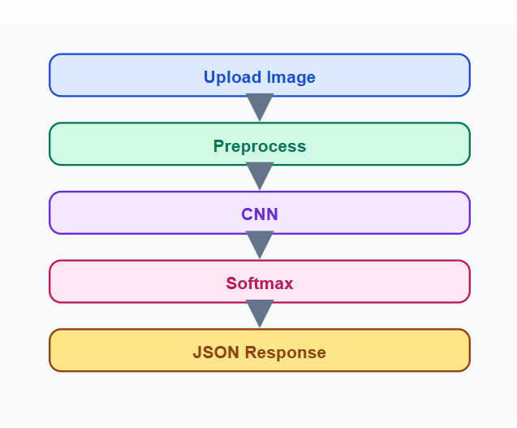

Step 4 — Why load the model outside?
Notice this part:
model = DigitCNN().to(DEVICE)
model.load_state_dict(...)
model.eval()
It is outside the endpoint.

Correct
model = DigitCNN()
Loads once when the server starts.

Wrong
@app.post("/predict")

model = DigitCNN()
Loads every request → very slow.
A senior deployment always loads the model one time.

Step 5 — Run the server
From the project root:
uvicorn app.api:app --reload
Expected output:
INFO: Uvicorn running on http://127.0.0.1:8000

Step 6 — Open Swagger
Open your browser:
http://127.0.0.1:8000/docs
You'll see an interactive API page.
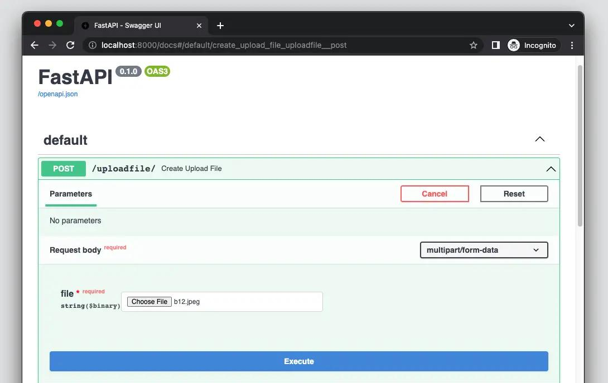
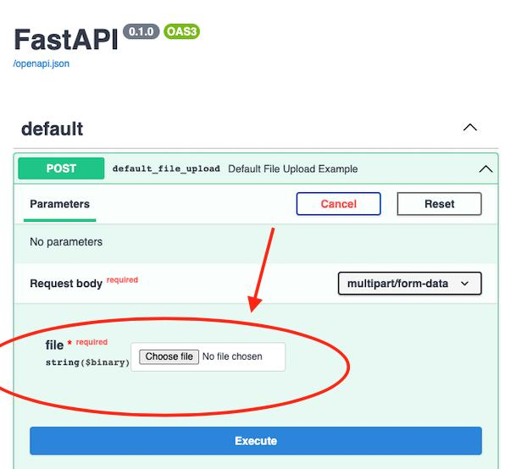
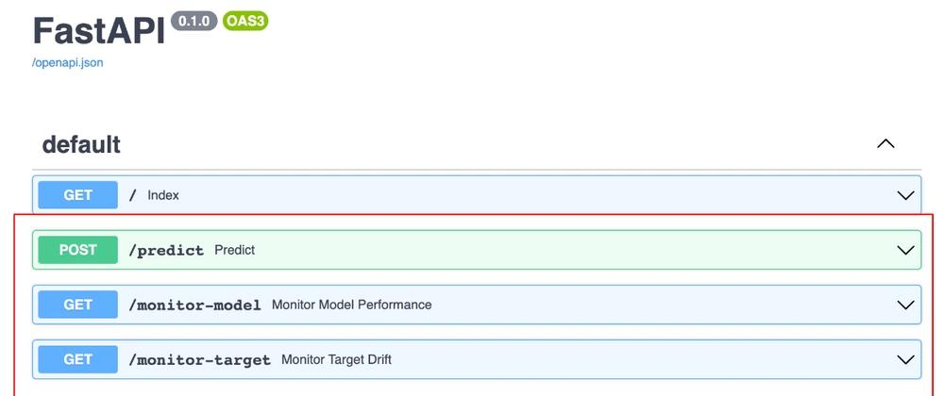
No frontend is needed.

Step 7 — Test
Upload sample.png.
Expected response:
{
"predicted_digit": 7,
"confidence": 0.9918
}

Step 8 — Production Flow
This architecture is exactly how your future Pneumonia Detection, Bone Fracture, YOLO, and Vision Transformer APIs will be deployed.
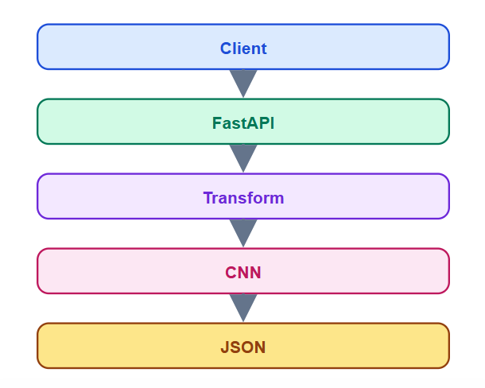

Step 21 Checklist
- Install fastapi, uvicorn, python-multipart
- Create app/api.py
- Load best_model.pth
- Create / endpoint
- Create /predict endpoint
- Run uvicorn app.api:app --reload
- Test in /docs
Step 21 is complete.
next

Step 22: Testing & Model Validation
Now we make sure your project is reliable, not just working once.

Goal
Test the different parts of your deep learning system:
- Dataset/DataLoader
- Model architecture
- Training components
- Saved model checkpoint
- Inference
- FastAPI endpoint

Step 22 Structure
We'll create:
tests/
├── test_dataset.py
├── test_model.py
├── test_inference.py
└── test_api.py
We will also use pytest.

1. Install pytest
From your project root:
pip install pytest

2. Create tests/test_dataset.py
New file:
tests/test_dataset.py
Add:
from src.dataset import get_dataloaders

def test_dataloader():

train_loader, val_loader, test_loader = get_dataloaders()

assert len(train_loader) > 0
assert len(val_loader) > 0
assert len(test_loader) > 0

def test_batch_shape():

train_loader, _, _ = get_dataloaders()

images, labels = next(iter(train_loader))

assert images.ndim == 4
assert labels.ndim == 1

assert images.shape[0] == labels.shape[0]

What are we checking?
Image
↓
DataLoader
↓
Batch
↓
[batch, channel, height, width]
For your MNIST CNN:
[64, 1, 28, 28]
and labels:
[64]

3. Create tests/test_model.py
New file:
tests/test_model.py
Add:
import torch

from src.model import DigitCNN
from src.config import DEVICE

def test_model_output_shape():

model = DigitCNN().to(DEVICE)

model.eval()

x = torch.randn(4, 1, 28, 28).to(DEVICE)

with torch.no_grad():

output = model(x)

assert output.shape == (4, 10)

def test_model_has_parameters():

model = DigitCNN()

parameters = list(model.parameters())

assert len(parameters) > 0

Why?
We want to guarantee:
4 images
↓
CNN
↓
4 predictions
↓
10 classes
Therefore:
input = [4, 1, 28, 28]

output = [4, 10]

4. Create tests/test_inference.py
New file:
tests/test_inference.py
Add:
from pathlib import Path

import torch

from src.model import DigitCNN
from src.config import DEVICE, CHECKPOINT_DIR

def test_checkpoint_exists():

checkpoint = CHECKPOINT_DIR / "best_model.pth"

assert checkpoint.exists()

def test_checkpoint_loads():

model = DigitCNN().to(DEVICE)

checkpoint = CHECKPOINT_DIR / "best_model.pth"

state_dict = torch.load(
checkpoint,
map_location=DEVICE
)

model.load_state_dict(state_dict)

model.eval()
This verifies that your saved:
best_model.pth
actually exists and can be loaded into your CNN.

5. Create tests/test_api.py
New file:
tests/test_api.py
Add:
from fastapi.testclient import TestClient

from app.api import app

client = TestClient(app)

def test_home():

response = client.get("/")

assert response.status_code == 200

data = response.json()

assert "message" in data
This checks whether your FastAPI server's root endpoint works.

6. Run ALL tests
From the project root, run:
pytest
You should see something similar to:
========================= test session starts =========================

tests/test_dataset.py .....
tests/test_model.py .....
tests/test_inference.py .....
tests/test_api.py .....

========================= 6 passed =========================
Your exact number may be different depending on the tests you have.

7. Run a specific test
For example:
pytest tests/test_model.py
Or:
pytest tests/test_dataset.py
Or:
pytest tests/test_api.py

Why this matters for a Senior Project
Without testing:
Code → Train → Hope it works
With testing:
Code
↓
Unit Tests
↓
Data Tests
↓
Model Tests
↓
Checkpoint Tests
↓
API Tests
↓
Training
↓
Deployment
This is a major difference between a student project and a more production-oriented ML project.

Step 22 Final Structure
Your project now looks approximately like:
MNIST Handwritten Digit Recognition using CNN/
│
├── app/
│ └── api.py
│
├── checkpoints/
│ └── best_model.pth
│
├── data/
│
├── notebooks/
│
├── outputs/
│ ├── training_log.csv
│ ├── loss_curve.png
│ └── accuracy_curve.png
│
├── src/
│ ├── config.py
│ ├── dataset.py
│ ├── transforms.py
│ ├── model.py
│ ├── engine.py
│ ├── train.py
│ ├── evaluate.py
│ ├── inference.py
│ ├── utils.py
│ ├── logger.py
│ ├── visualize.py
│ └── gradcam.py
│
├── tests/
│ ├── test_dataset.py
│ ├── test_model.py
│ ├── test_inference.py
│ └── test_api.py
│
├── requirements.txt
├── README.md
└── .gitignore

✅ Step 22 complete when:
pytest
runs successfully.
Next: Step 23 — Requirements & Reproducibility.
Next

Step 23: Requirements & Reproducibility
Now we make sure another developer—or you six months from now—can recreate the same project environment and results.
This is an important part of professional ML engineering.

What we will do
We will update 2 files:
File | Action
requirements.txt | Update dependencies
src/config.py | Verify reproducibility settings

1. Update requirements.txt

File
requirements.txt
Replace its contents with:
torch
torchvision
numpy
pandas
matplotlib
opencv-python
pillow
fastapi
uvicorn
python-multipart
pytest
These are the main packages your current project uses.

2. Generate the exact environment
Since you're already inside your project's .venv, run:
pip freeze > requirements.txt

Important
This command will replace the manually written file with the exact versions installed in your environment.
For example:
torch==2.5.1
torchvision==0.20.1
numpy==...
pandas==...
This is better for reproducibility because another machine can install the same versions.

3. Check your Python version
Run:
python --version
You previously had Python 3.13, so you'll see something similar to:
Python 3.13.x
For a professional project, record this in your README later.

4. Check PyTorch and CUDA
Run:
python -c "import torch; print('PyTorch:', torch.__version__); print('CUDA available:', torch.cuda.is_available()); print('CUDA version:', torch.version.cuda)"
You want to know:
PyTorch: ...
CUDA available: True/False
CUDA version: ...
This is especially important because deep learning environments depend heavily on the PyTorch + CUDA + GPU combination.

5. Verify src/config.py

File:
src/config.py
Make sure you have:
SEED = 42
And your device configuration should be something like:
DEVICE = "cuda" if torch.cuda.is_available() else "cpu"
If your config.py currently uses torch, make sure it has:
import torch
at the top.

6. Why SEED = 42 matters
Remember this from our training discussion:
set_seed(SEED)
This makes random operations more consistent.
For example:
Experiment 1
↓
Seed = 42
↓
Same initialization/randomness
↓
More reproducible result
Without a seed:
Run 1 → 98.1%
Run 2 → 97.8%
Run 3 → 98.4%
With controlled randomness, results are generally much more consistent.
Important: A seed does not guarantee perfectly identical results across every GPU, operating system, PyTorch/CUDA version, or hardware configuration. It improves reproducibility; it doesn't magically eliminate all nondeterminism.

7. Test that the environment works
Run:
python -c "import torch; import torchvision; import pandas; import matplotlib; import cv2; import fastapi; print('Environment OK')"
Expected:
Environment OK

8. Test the complete project
Now run your tests:
pytest
Then train:
python -m src.train
If both work, your environment and project are reproducible enough for this stage.

Step 23 Deliverables
You should now have:
requirements.txt
↓
Exact project dependencies

config.py
↓
Seed + device + experiment configuration

.venv
↓
Isolated environment

pytest
↓
Project verification

✅ Step 23 is complete when:
pip freeze > requirements.txt
then:
pytest
passes successfully.

Step 24: Professional GitHub Documentation
This step is about making your GitHub repository look like a senior AI engineer's project, not just a folder of code.
Goal: Create a README that explains the problem, architecture, results, setup, and usage.

Files to update
File | Action
README.md | Create/Replace
.gitignore | Create
Your final repository should look like:
MNIST Handwritten Digit Recognition using CNN/
│
├── README.md
├── .gitignore
├── requirements.txt
├── app/
├── checkpoints/
├── outputs/
├── src/
└── tests/

1. Create .gitignore
File: .gitignore
Paste:
# Python
__pycache__/
*.pyc

# Virtual Environment
.venv/
venv/

# Jupyter
.ipynb_checkpoints/

# OS
.DS_Store
Thumbs.db

# Logs
*.log

# Pytest
.pytest_cache/

# IDE
.vscode/
.idea/
Purpose: Prevent unnecessary files from being uploaded to GitHub.

2. Create README.md
File: README.md
Use this structure.
MNIST Handwritten Digit Recognition using CNN
# MNIST Handwritten Digit Recognition using CNN

A production-style Deep Learning project built with **PyTorch** that recognizes handwritten digits using a custom Convolutional Neural Network (CNN).

## Business Problem

Banks, postal services, and document processing systems need to automatically recognize handwritten digits from scanned documents. This project builds an end-to-end AI solution for that task.

## Dataset

- **Name:** MNIST
- **Training:** 60,000 images
- **Testing:** 10,000 images
- **Classes:** 10 (0–9)
- **Image Size:** 28×28 grayscale

## Project Architecture

```text
src/
├── config.py
├── dataset.py
├── transforms.py
├── model.py
├── engine.py
├── train.py
├── evaluate.py
├── inference.py
├── gradcam.py
├── logger.py
├── visualize.py
└── utils.py
```

## CNN Architecture

- Conv2D
- ReLU
- MaxPool
- Conv2D
- ReLU
- MaxPool
- Fully Connected
- Dropout
- Softmax

## Technologies

- Python
- PyTorch
- FastAPI
- OpenCV
- Pandas
- Matplotlib
- Pytest

## Training Configuration

| Parameter | Value |
| -------------- | -----: |
| Epochs | 20 |
| Batch Size | 64 |
| Learning Rate | 0.001 |
| Optimizer | Adam |
| Scheduler | StepLR |
| Early Stopping | 3 |

## Results

The project automatically generates:

- Accuracy
- Precision
- Recall
- F1 Score
- Confusion Matrix
- Loss Curve
- Accuracy Curve
- Grad-CAM Visualization

## Run Training

```bash
python -m src.train
```

## Evaluate

```bash
python -m src.evaluate
```

## Inference

```bash
python -m src.inference
```

## Grad-CAM

```bash
python -m src.gradcam
```

## FastAPI

```bash
uvicorn app.api:app --reload
```

Open:

`http://127.0.0.1:8000/docs`

## Project Status

- Data Pipeline
- CNN Training
- Evaluation
- Error Analysis
- Grad-CAM
- FastAPI Deployment
- Unit Testing

## Author

**Robel Gebregziabher**

AI Engineering & Computer Vision Portfolio

3. Add repository topics on GitHub
After pushing, add these GitHub Topics:
deep-learning
pytorch
computer-vision
cnn
mnist
fastapi
artificial-intelligence
They improve discoverability.

4. Repository description
On GitHub, set the repository description to:
Production-ready CNN for handwritten digit recognition using PyTorch, Grad-CAM, FastAPI, and professional ML engineering practices.

Step 24 Checklist
- Create README.md
- Create .gitignore
- Add project architecture
- Document commands
- Add technologies
- Add GitHub topics
- Add repository description
This is what recruiters will read before looking at your code.

Step 25: Production Optimization & Packaging (Final Senior Step)
Congratulations. This is the last step of Project 01.
The model already works. Now we prepare it like a production-ready AI application that can be shared, deployed, and maintained.
Goal: Package the project so another engineer can clone it, install it, run it, and deploy it with minimal effort.

What Step 25 includes
Area | Deliverable
Project Packaging | Clean folder structure
CLI Commands | One-command execution
Model Versioning | Versioned checkpoints
Release Assets | Best model + requirements
Deployment Ready | FastAPI + reproducible environment

1. Final Project Structure
Your repository should end like this:
MNIST Handwritten Digit Recognition using CNN/
│
├── app/
│ └── api.py
│
├── checkpoints/
│ ├── best_model.pth
│ └── last_checkpoint.pth
│
├── data/
│
├── outputs/
│ ├── metrics.json
│ ├── training_log.csv
│ ├── confusion_matrix.png
│ ├── loss_curve.png
│ ├── accuracy_curve.png
│ └── wrong_predictions.png
│
├── src/
│ ├── config.py
│ ├── dataset.py
│ ├── transforms.py
│ ├── model.py
│ ├── engine.py
│ ├── checkpoint.py
│ ├── logger.py
│ ├── visualize.py
│ ├── gradcam.py
│ ├── evaluate.py
│ ├── inference.py
│ ├── train.py
│ └── utils.py
│
├── tests/
│
├── requirements.txt
├── README.md
└── .gitignore
This is the structure you'll reuse for all 20 deep learning projects.

2. Version your model
Inside config.py, add:
File: src/config.py
PROJECT_NAME = "MNIST CNN"

MODEL_VERSION = "1.0.0"
Now every saved model belongs to a version.
Later you'll have:
best_model_v1.0.0.pth
best_model_v1.1.0.pth
instead of overwriting models.

3. Add a command section to README
At the bottom of README.md, add:
## Quick Start

Install dependencies

```bash
pip install -r requirements.txt
```

Train

```bash
python -m src.train
```

Evaluate

```bash
python -m src.evaluate
```

API

```bash
uvicorn app.api:app --reload
```
This allows anyone to run your project in minutes.

4. Create your first GitHub Release
After pushing the repository:
- Go to GitHub → Releases
- Click Create Release
- Tag:
v1.0.0
Release title:
MNIST CNN Version 1.0.0
Attach:
- best_model.pth
- requirements.txt
This is how professional ML repositories distribute trained models.

5. Final verification
Run these commands from the project root:
pytest
python -m src.train
python -m src.evaluate
python -m src.gradcam
uvicorn app.api:app --reload
If all five work, your project is production-ready.

Complete 25-Step Framework Status
Stage | Status
Project Definition | ✅
Dataset & EDA | ✅
Data Pipeline | ✅
CNN Architecture | ✅
Training Engine | ✅
Validation | ✅
Scheduler | ✅
Early Stopping | ✅
Checkpointing | ✅
Logging | ✅
Learning Curves | ✅
Evaluation | ✅
Error Analysis | ✅
Inference | ✅
Grad-CAM | ✅
FastAPI | ✅
Testing | ✅
Reproducibility | ✅
GitHub Documentation | ✅
Production Packaging | ✅

What you've built
You didn't just build an MNIST classifier—you built a production-style computer vision template.
This same architecture can now be reused for:
- Fashion-MNIST
- CIFAR-10
- Cats vs Dogs
- Pneumonia Detection
- Bone Fracture Detection
- Brain Tumor Classification
- YOLO Projects
- U-Net Segmentation
- Vision Transformers

Step 26 Architecture
MNIST Handwritten Digit Recognition using CNN/
│
├── app/
│ ├── api.py
│ └── streamlit_app.py ← NEW
│
├── checkpoints/
│ └── best_model.pth
│
├── src/
│ ├── model.py
│ └── config.py

1. Install Streamlit
Run in your virtual environment:
pip install streamlit

2. Create app/streamlit_app.py
File: app/streamlit_app.py
Paste this complete code:

import sys
from pathlib import Path

# -----------------------------
# Make project root importable
# -----------------------------
ROOT = Path(__file__).resolve().parents[1]
sys.path.append(str(ROOT))

import streamlit as st
import torch
from PIL import Image
from torchvision import transforms

from src.model import DigitCNN
from src.config import DEVICE, CHECKPOINT_DIR

# -----------------------------
# Page Configuration
# -----------------------------
st.set_page_config(
page_title="MNIST Digit Classifier",
page_icon="🔢",
layout="centered"
)

st.title("🔢 MNIST Handwritten Digit Recognition")
st.write("Upload a handwritten digit image (0–9).")

# -----------------------------
# Image Transform
# -----------------------------
transform = transforms.Compose([
transforms.Grayscale(),
transforms.Resize((28, 28)),
transforms.ToTensor(),
transforms.Normalize((0.1307,), (0.3081,))
])

# -----------------------------
# Load Model
# -----------------------------
@st.cache_resource
def load_model():

model = DigitCNN().to(DEVICE)

model.load_state_dict(
torch.load(
CHECKPOINT_DIR / "best_model.pth",
map_location=DEVICE
)
)

model.eval()

return model

model = load_model()

# -----------------------------
# Upload Image
# -----------------------------
uploaded_file = st.file_uploader(
"Choose an image",
type=["png", "jpg", "jpeg"]
)

if uploaded_file is not None:

image = Image.open(uploaded_file)

st.image(
image,
caption="Uploaded Image",
width=220
)

if st.button("Predict"):

img = transform(image).unsqueeze(0).to(DEVICE)

with torch.no_grad():

outputs = model(img)

probabilities = torch.softmax(outputs, dim=1)

confidence, prediction = torch.max(
probabilities,
1
)

st.success(f"Prediction: {prediction.item()}")

st.metric(
"Confidence",
f"{confidence.item()*100:.2f}%"
)

st.subheader("Class Probabilities")

probs = probabilities.squeeze().cpu().numpy()

for i, p in enumerate(probs):

st.progress(float(p))

st.write(f"Digit {i}: {p*100:.2f}%")

3. Update requirements.txt
Add this line:
streamlit

4. Run the Frontend
From the project root, run:
streamlit run app/streamlit_app.py

5. What the UI looks like
The interface will have:
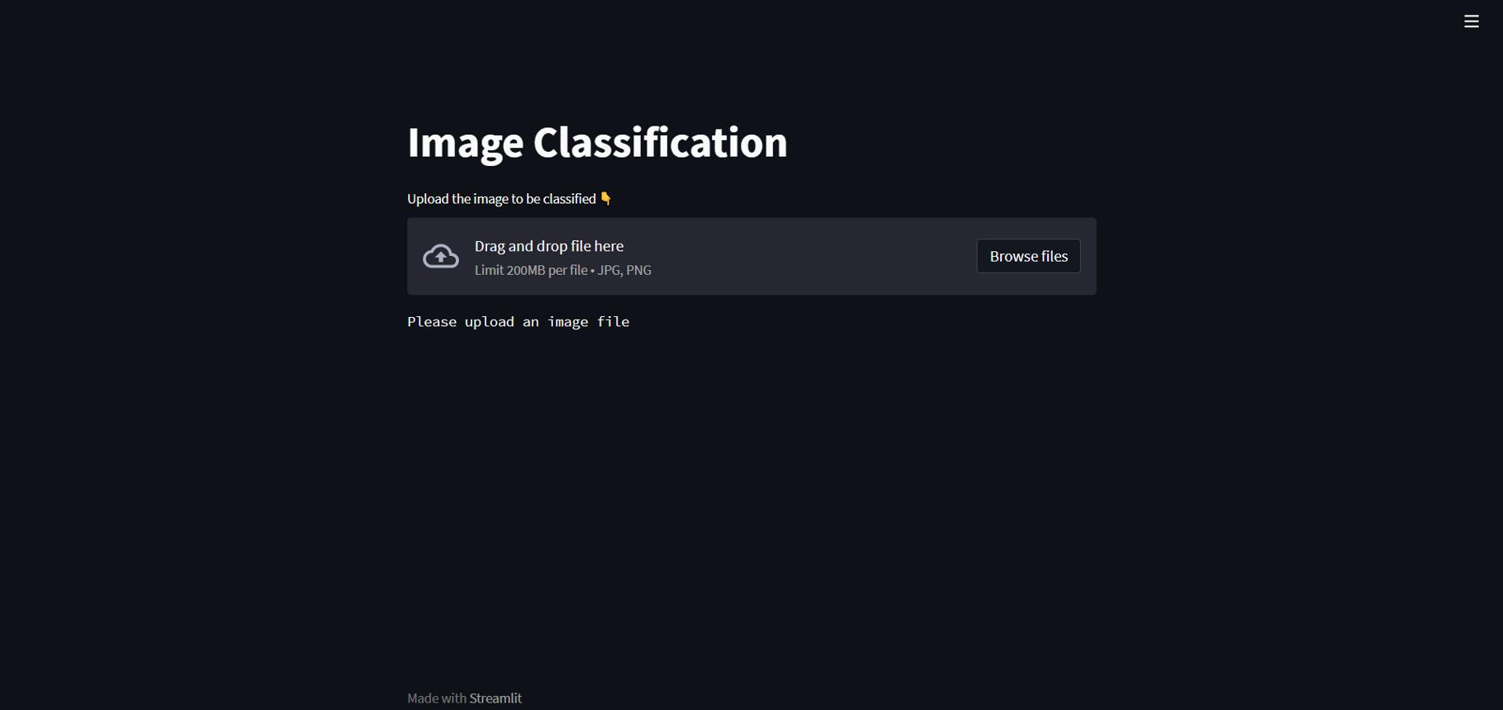
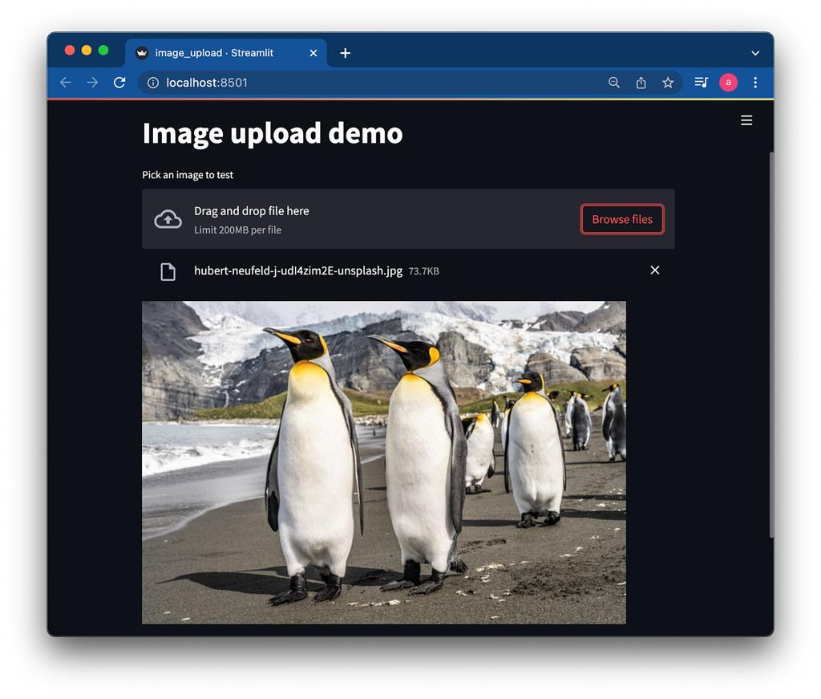
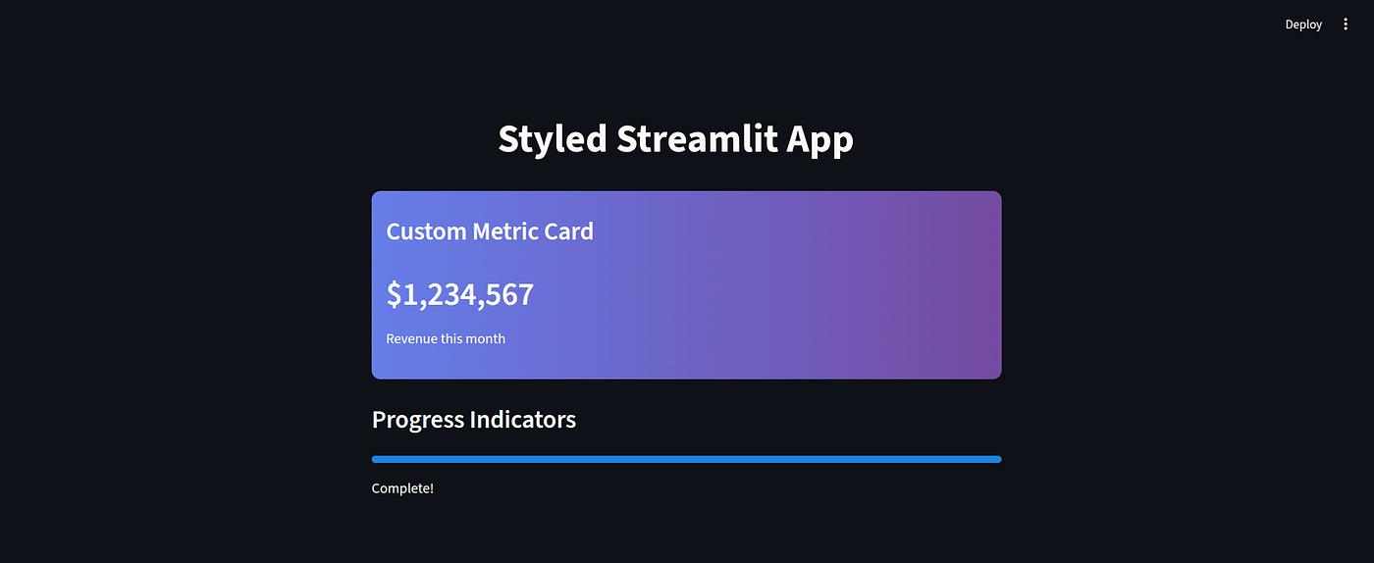

Features
- Upload PNG/JPG
- Image preview
- Predict button
- Predicted digit
- Confidence percentage
- Probability bars for all 10 classes

6. User Flow

7. Final Project Structure
MNIST Handwritten Digit Recognition using CNN/
│
├── app/
│ ├── api.py
│ └── streamlit_app.py
│
├── checkpoints/
│ └── best_model.pth
│
├── outputs/
│
├── src/
│
├── tests/
│
├── README.md
├── requirements.txt
└── .gitignore

